SUBCOURSE EDITION
MM 0099 A

BASIC MATHEMATICS



3 CREDIT HOURS
REVIEWED: 1988

SECTION 1

TABLE OF CONTENTS

Page

Objectives ii

How to Use This Book iii

Graphic Chart of Math Terms v

Frames - By Subject

Addition 1

Subtraction 2

Multiplication 4

Division 6

Fractions 11

Decimals 41

Metric Prefixes 56

Square Root 66

Mathematics Tables

Addition 75

Subtraction 75

Multiplication 76

Division 76

Squares and Square Roots 77

Metric Data Conversion Sheet 78

Self Quiz 80

Answers To Quiz 86

REVIEWED AND REPRINTED WITH MINOR REVISIONS JAN 76.
i

OBJECTIVES

As a result of taking this program of BASIC MATHEMATICS, you must be able to:

1. Use addition up to seven digits in solving electrical circuit problems, to include the carrying of digits.

2. Use subtraction up to seven digits in solving electrical circuit problems.

3. (Having proficiency in the multiplication table up to the 9x9 level) Use multiplication in solving electrical circuit problems.

4. Use long division in solving electrical circuit problems.

5. Use fractions in solving common electrical circuit problems.

6. Use decimals in solving common electrical circuit problems.

7. (With the aid of references)

a. Identify these metric prefixes: mega, milli, kilo, micro, and micro-micro.

b. Determine the value of the metric prefixes.

c. Replace the metric prefixes with the proper symbols.

d. Convert metric prefixes into their larger or smaller equivalents. For example: 1 kilovolt equals 1,000 volts.

8. Calculate square root commonly found in radio formulas.

PLEASE NOTE

Proponency for subcourse has changed
from Signal (SS) to Missile & Munitions (MM).

ii

HOW TO USE THIS BOOK

This is a self-instructional programmed course designed to help you review BASIC MATHEMATICS.

As you go through this book you will observe that it is systematically arranged in small simple learning steps called frames.

Because the purpose is to teach rather than merely present information, a single point may be repeated several times in different ways. What may seem to you like needless repetition in any other kind of reading is done here to reinforce learning.

SECTION 1

Each individual instructional unit or bit of information is called a frame. Each frame requires you to DO something: read the frame as informational, solve a problem, fill in a box, select an alternate, or write a phrase. Immediately thereafter, if the frame was not informational, (in the box below and to the left of the next frame) you will find the correct response and can compare your answer to it. For example:

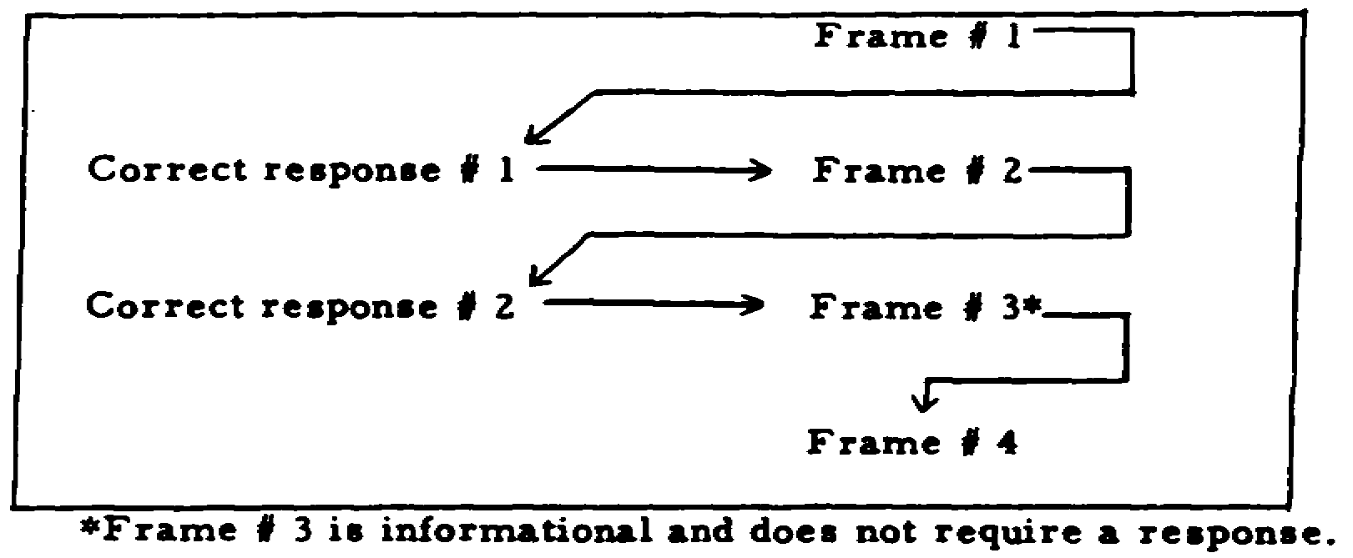

If you were right, your response is immediately confirmed and the point you learned is thus reinforced. If you did not respond correctly you discover this immediately and learn what was the correct response. When you learn the correct response you can go ahead and build up your knowledge slowly but surely.

iii

You will not have any other teacher for this material. This text is your teacher. Rely on it. It has been tested and proved an effective teacher. To get the best instruction, however, do not cheat by peeking ahead at the correct response. You are deceiving only yourself. Make an honest effort to do what is expected, and then compare your answer with the correct response.

Since this is a review subject, you are expected to know some areas of knowledge herein. We have built in certain frames to check this knowledge and save you the task of studying frames on subject matter you already know. If you answer these diagnostic frames correctly, you will be told TO SKIP AHEAD A CERTAIN NUMBER OF FRAMES. Be sure to do this so that you will be able to complete the text within the allotted training time.

*** IMPORTANT NOTICE ***

THE PASSING SCORE FOR ALL ACCP MATERIAL IS NOW 70%.

PLEASE DISREGARD ALL REFERENCES TO THE 75% REQUIREMENT.

iv

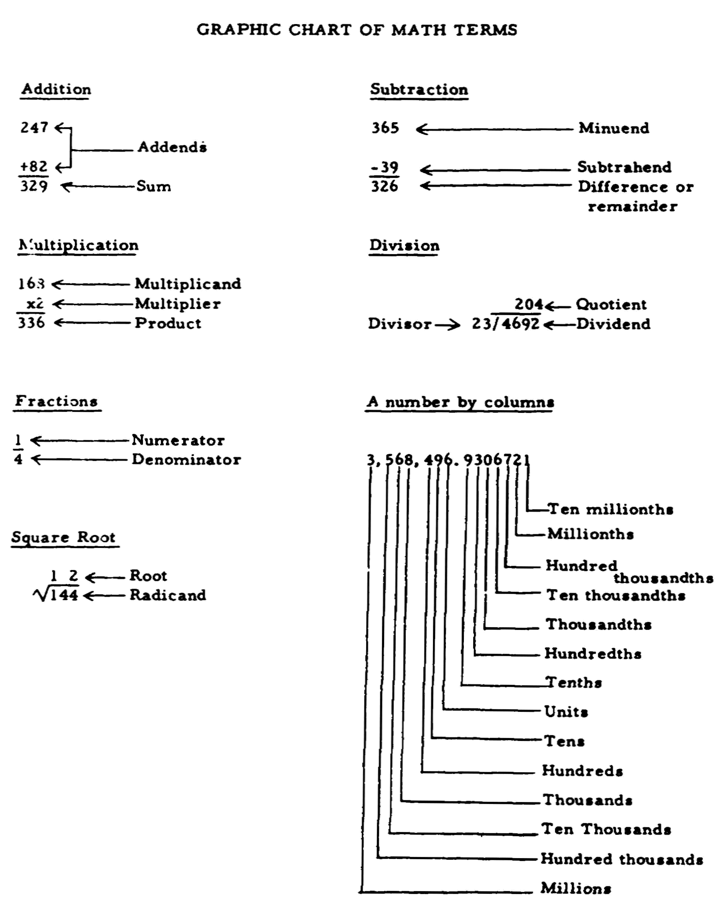

v

Before proceeding with the required material, we want you to know that there are addition, subtraction, multiplication, division, and squares and square root tables at the end of this book. If you feel you need a quick refresher before proceeding with the frames, please check these tables.

We teach one method of mathematics, but there are many other methods too. You may use our method or your own method as long as you obtain correct results.

Okay, ready? Begin.

ADDITION
(1)
To review addition, do the following problems:
1,286 + 63 =

279,832 + 23,897 =
(1)
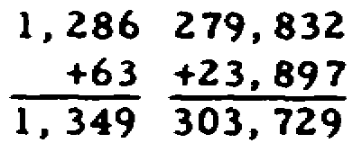

1

 | SUBTRACTION
 | (2)
 | Now let's try SUBTRACTION.
 | 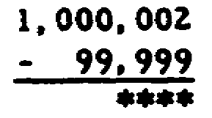
 | ****Note - whenever this symbol **** is used
 | DO NOT WORK THE PROBLEM because this is simply a sample problem for explanation purposes.
 | Before finding the difference for the above problem, we first must borrow 10 from the tens column so that we can subtract 9 from a number that is either equal to or larger than it. (In this example, we have to go left all the way to the millions column to get the 10.)
 | 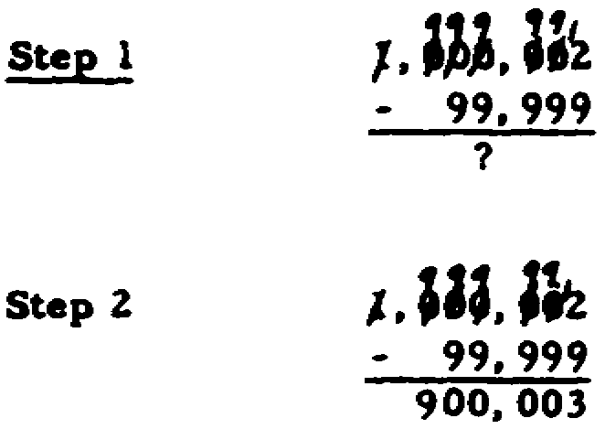
 | (3) Let's practice:
 | 800,701 56, 002
 | - 692 - 9,007
(3) | (4)
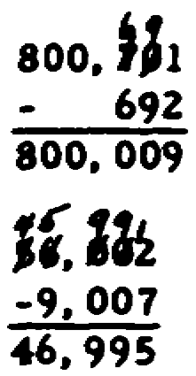 | 1,007,802 7,008,324
 | - 8,933 - 989,655

2

(4) | (5)
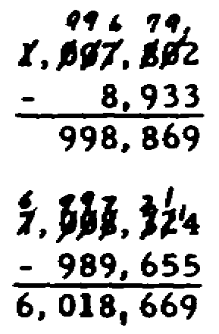 | To review: 30 - 10 + 6 =
(5) | (6)
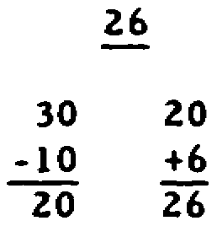
 | 10 + 7 - 8=

3

 | MULTIPLICATION
(6) | (7)
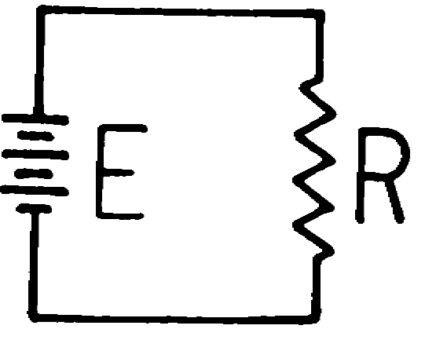  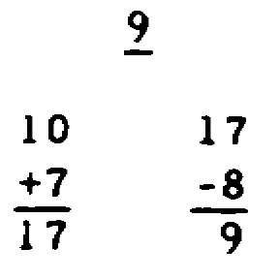 | Now MULTIPLICATION:
E = I x R

R has a value of 4 ohms and I has a value of 3 amperes.

The value of E is _____ volts.
(7) | (8)
12 | 9 x 0 x 6=
I x R = E
3 x4 = 12
(8) | (9)
0 | 6 x 4 x 3=
IF YOU DID NOT ARRIVE AT THE CORRECT ANSWERS, REVIEW THE MULTIPLI-CATION TABLE AT THE END OF THIS BOOK BEFORE PROCEEDING TO THE NEXT FRAME.
(9) | (10)
72 | Sometimes to avoid confusion, a complicated expression must be inclosed in parentheses ( ), brackets [ ], or braces { }.
 | When multiplying quantities containing parentheses, brackets, or braces, you first complete the operation required within the parentheses (brackets or braces) and then multiply the quantities. For example: [4 + 7 + 2] [5 x 3] equals
 | [13] [15] or 13 x 15. 13 x 15 = 195.
 | To practice:
 | (2) (4) (3) =

4

(10) | (11)
24 | (200) (6) (7) =
(11) | (12)
8,400 | (50) (0) (2) =
(12) | (13)
0 | (4 x 3) (2 + 5) =
(13) | (14)
84 | (6 + 0) (5 - 1) =
(4 x 3) (2 + 5) =
(12) (7) = 84

5

 | DIVISION
(14) | (15)
(6) (4) = 24 | Good, now let's try DIVISION:
 | 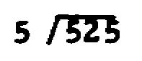
(15) | (16)
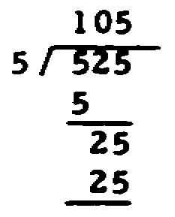 | 96/16 =

6

(16) | (17)
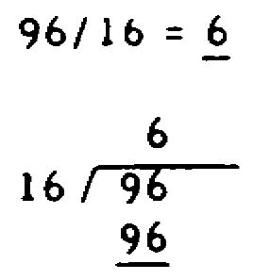 | Well done. Now let's try some harder problems.
 | 25876 ÷ 27 =
 | 33682 ÷ 876 =

7

(17) |  | (18)  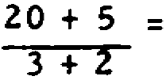  (Complete the required operation on the numerator. Then do what is required on the denominator.)
958 10/27, 38 197/438
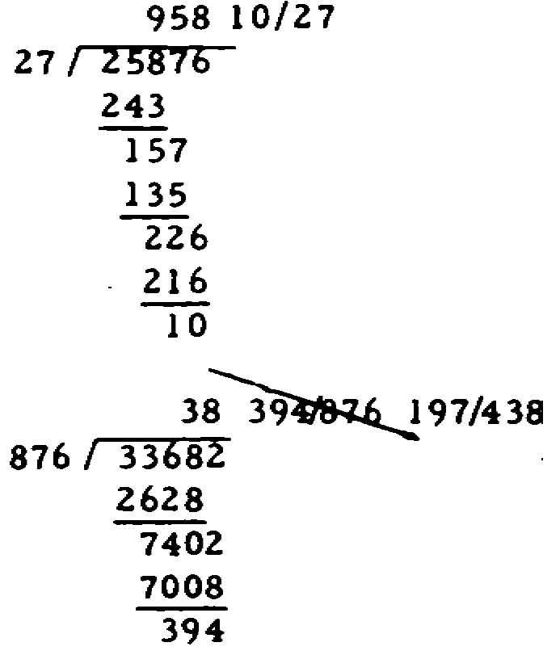
 | IF YOU FEEL YOU NEED MORE PRACTICE, DO THE REMAINING FRAMES ON DIVISION; OTHERWISE, SKIP TO FRAME NUMBER 24.
(18) |  | (19)
5 |  | 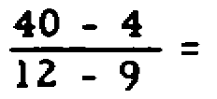
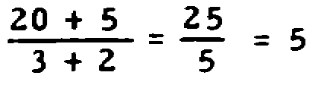
(19) |  | (20)
12 |  | 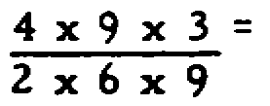
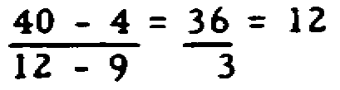

8

(20) | (21)
1 | 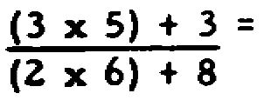
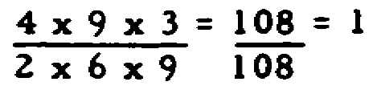
(21) | (22)
9/10 | 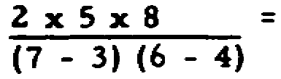
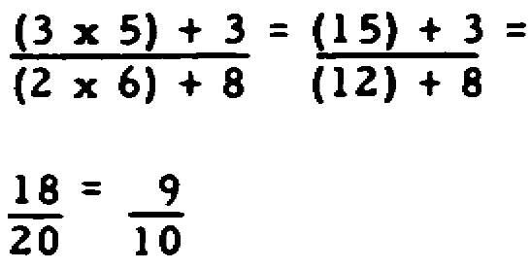
(22) | (23)
10 | 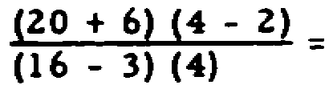
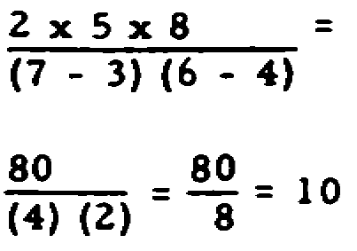

9

(23)
1
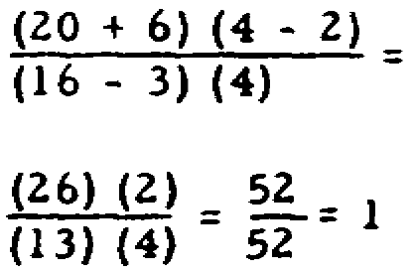

10

FRACTIONS
 | (24)
D | Very good. Now let's get into something a
I | little more difficult, FRACTIONS.
A F
G R | To practice:
N A
O M | 5/6 + 3/8 + 2/5 =
S E
T
I
C
S
(24) 1 73/120

Solution: 6 X 8 X 5 = 240

240 ÷ 6 40 240 ÷ 8 = 30 240 ÷ 5 = 48

40 X 5 = 200 30 X 3 = 90 48 X 2 = 96

200/240 + 90/240 + 96/240 = 386/240 = 1 146/240 = 1 73/120

IF YOU ANSWERED THIS PROBLEM CORRECTLY SKIP TO FRAME NUMBER 48; OTHERWISE, BEGIN WITH THE NEXT FRAME.

11

 | (25)
 | 1/4 - 1/2 ****
 | 4 and 2 are called DENOMINATORS
 | The bottom part of a fraction is called the ______________________________.
(25) | (26)
denominator | 1/4 ÷ 1/2 = *
 | 1 and 1 are the numerators.
 | The upper part of a fraction is called a ______________________________.

12

(26) | (27)
numerator | Fractions which can be REDUCED to a whole number should be reduced. To REDUCE a fraction to a whole number, divide the denominator into the numerator.
 | 9/3 = 3
 | To practice:
 | 8/4 =
(27) | (28)
2 | Any fraction greater than 1 can be reduced either to a whole number or a mixed number. A MIXED NUMBER contains both a whole number and a fraction. Some fractions can be reduced to a mixed number. To obtain a mixed number, divide the denominator into the numerator.
 | 10/3 = 3 1/3
 | To practice:
 | 22/7 =
(28) | (29)
3 1/7 | Fractions whose numerator and denominator are divisible by the same digit can be reduced by dividing both the numerator and denominator by this digit. THIS DOES NOT CHANGE THE VALUE OF THE FRACTION!
 | 16/32 = ?
 | 16/32 = 1/2
 | The numerator and the denominator are divisible by 2, 4, 8, or 16. Dividing by 16 will give you the lowest equivalent fraction.
 | To practice:
 | 24/72 =

13

(29) | (30)
1/3 | To review the statement that reducing a fraction does NOT change its value:
 | 16/32 has the same value as 8/16 or as 4/8
 | or
 | 16/32 = 8/16 = 4/8 = 1/2
 | Remember to reduce all fractions to their LOWEST terms.
 | (31)
 | 1/4 + 1/2 = ****
 | In order to add fractions, you must find a number into which the denominators will divide. This is called a COMMON DENOMINATOR. The number into which the denominators of all fractions to be added will divide is the _______________ _______________.
(31) | (32)
1/4 + 1/2 = **** | To find the common denominator, we try the inspection method first. By inspecting the problem, we notice that there are many numbers (such as 4, 8, 16, 4000, etc.) into which both denominators will divide. However, we want the smallest of these numbers, to simplify working the problem. This number, called the lowest common denominator or l.c.d., is _______________.
common denominator

14

(32) | (33)
4 | 1/4 + 1/2 = ****
 | You wish to convert 1/2 into an equivalent fraction with a denominator of 4. To do so you divide 4 by 2 and arrive at an answer of 2. Since the denominator must be multiplied by 2 to get four, the numerator must also be multiplied by _______________ to keep the fraction equivalent.
(33) | (34)
2 | 1/2 x 2/2 =
 | 1/2 x 2/2 = 2/4
 | 1/4 + 2/4 = (Finish working the problem)
(34) | (35)
3/4 | 3/4 is an example of a PROPER FRACTION--one whose value is less than unity (Unity = 1).  A fraction whose value is less than unity is called a ________________ fraction.
1/4 + 2/4 = 3/4

15

(35) | (36)
proper | 257/120 is an example of an IMPROPER FRACTION  --one whose value is greater than unity.
 | A fraction whose value is greater than unity is a (an) _______________ fraction.
(36) | (37)
improper | Improper fractions can not be left in this unfinished state (257/120) but must be changed to a mixed number--one in which we have both a whole number and a fraction. A mixed number can be obtained by dividing the numerator by the denominator.
 | A mixed number of 257/120 would be _______________.
(37) | (38)
2 17/120 | When one has both a whole number and a fraction, one has a __________ __________.
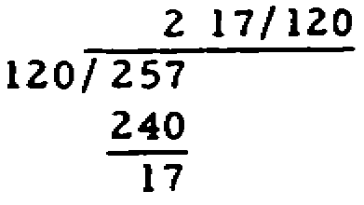

16

(38) | (39)
mixed number | Fine. Now let's tackle something a little bit harder. If you cannot secure the lowest common denominator (l.c.d.) which is divisible into all denominators, multiply the denominators and the product will be the l.c.d.
 | The l.c.d. of 2/3 + 4/7 + 1/2 is
 | 3 x 7 x 2 = 42
 | (40)
 | 2/3 + 4/7 + 1/2 = ****
 | In order to add these fractions we must change them so all the denominators are the same.
 | To change these fractions, divide the denominator into the l.c.d. and multiply the numerator and denominator by this number. For example: 2/3, first divide 3 into 42, which equals 14. Multiply the fraction 2/3 x 14/14 = 28/42
 | 4/7, divide 7 into 42 which is 6. Multiply 4/7 x 6/6 = 24/42.
 | 1/2, divide 2 into 42 which is 21. Multiply 1/2 x 21/21 = 21/42.
 | 2/3 + 4/7 + 1/2 = 28/42 + 24/42 + 21/42
 | 28/42 + 24/42 + 21/42 = 73/42 = 1 31/42

17

 | (41)
 | Let's practice:
 | 5/6 + 3/5 + 1/4 =
(41) | (42)
1 41/60 | 2/3 + 3/5 + 1/7 =
6 x 5 x 4 = 120
120 ÷ 6 = 20, 120 ÷ 5 = 24, 120 ÷ 4 = 30
20 x 5 = 100, 24 x 3 = 72, 30 x 1 = 30
100/120 + 72/120+ 30/120 =
202/120 = 1 82/120 = 1 41/60

18

(42) | (43)
1 43/105 | 1/3 + 5/8 + 4/5 =
3 x 5 x 7 = 105
105 ÷ 3 = 35, 105 ÷ 5 = 21, 105 ÷ 7 = 15
35 x 2 = 70, 21 x 3 = 63, 15 x 1 = 15
70/105 + 63/105 + 15/105 = 148/105 = 1 43/105

(43) | (44)
1 91/120 | 5/9 + 4/7 + 2/5 =
3 x 8 x 5 = 120
120 ÷ 3 = 40, 120 ÷ 8 = 15, 120 ÷ 5 = 24
40 x 1 = 40, 15 x 5 = 75, 24 x 4 = 96
40/120 + 75/120 + 96/120 = 211/120 = 1 91/120
IF YOU GOT THE LAST THREE (3) PROBLEMS CORRECT AND DO NOT FEEL THAT YOU NEED ADDITIONAL PRACTICE, SKIP TO FRAME NUMBER 48; OTHERWISE, CONTINUE WITH THE NEXT FRAME.

19

(44) | (45)
1 166/315 | 1/8 + 3/7+ 2/3 =
9 x 7 x 5 = 315
315 ÷ 9 = 35, 315 ÷ 7 = 45 315 ÷ 5 = 63
35 x 5 = 175, 45 x 4 = 180 63 x 2 = 126
175/315 + 180/315 + 126/315 = 481/315 = 1 166/315
(45)
1 37/168 | IF YOU GOT THE LAST TWO (2) FRAMES CORRECT AND THINK YOU UNDERSTAND HOW TO DO THESE, SKIP TO FRAME NUMBER 48. IF NOT, CONTINUE.
8 x 7 x 3 = 168
168 ÷ 8 = 21, 168 ÷ 7 = 24, 168 ÷ 3 = 56
21 x 1 = 21, 24 x 3 = 72, 56 x 2 = 112
21/168 + 72/168 + 112/168 = 205/168 = 1 37/168
 | (46) 2/3 + 1/2 + 3/8 =

20

(46) | (47)
1 13/24 | 3/4 + 1/6 + 3/5 =
3 x 2 x 8 = 48
48 ÷ 3 = 16, 48 ÷ 2 = 24, 48 ÷ 8 = 6
16 x 2 = 32, 24 x 1 = 24, 6 x 3 = 18
32/48 + 24/48 + 18/48 = 74/48 = 1 26/48 = 1 13/24
(47)
1 31/60
4 x 6 x 5 . 120
120 ÷ 4 = 30 120 ÷ 6 = 20 120 ÷ 5 = 24
30 x 3 = 90 20 x 1 = 20 24 x 3 = 72
90/120 + 20/120 + 72/120 = 182/120 = 1 62/120 = 1 31/60

21

(48)
Well done. Now let's try SUBTRACTION OF FRACTIONS.
Subtract 1/8 from 2/7.
D
I
A
G F
N R
O A
S M
T E
I
C

(48)
9/56
2/7 - 1/8 =
16/56 - 7/56 =
16/56 - 7/56 = 9/56
IF YOU ANSWERED THE PROBLEM CORRECTLY, SKIP TO FRAME NUMBER 62; OTHERWISE, BEGIN WITH THE NEXT FRAME.

22

 | (49)
 | 3/4 - 1/2 =****
 | A number into which the denominators will divide is called the _________ ______________.
(49) | (50)
common denominator | 3/4 - 1/2 = ****
 | By the inspection method, you can see that the perfect dividend for both denominators - in other words the smallest number in which both denominators will divide evenly - will be the number __________.

23

(50) | (51)
4 | 3/4 - 1/2 = ****
 | To subtract fractions you must make the denominators the same.
 | The equivalent fraction of 1/2 is .
(51) | (52)
2/4 | To practice:
3/4 - 1/2 x 2/2 = 3/4-2/4 | 3/4 - 2/4 =
2/4 = 1/2
(52) | (53)
1/4 | 1/4 is an example of a __________ fraction.
We subtract the numerator after the subtraction sign and carry over the l.c.d.
(53) | (54)
proper | A proper fraction is defined as one whose value is _______________ than unity.

24

(54) | (55)
less | 2/5 - 1/3 = ****
 | To subtract fractions whose denominators do not have a common dividend, you must multiply the denominators and the product is your l.c.d. In the above problem, 15 is the l.c.d. (5 x 3 = 15).
 | 4/7 - 3/4 = ****
 | The l.c.d. is ______________.
(55) | (56)
28 | 2/5 - 1/3 = ****
 | 2/5 - 1/3 can be expressed in EQUIVALENT FRACTIONS BY __________ - __________.
(56) | (57)
6/15 - 5/15 | To practice:
2/5 x 3/3 - 1/3 x 5/5 = | 6/15 - 5/15 =
6/15 - 5/15
(57) | (58)
1/15 | 5/7 - 1/3 =
We subtract the numerator after the subtraction sign and carry over the l.c.d.

25

(58) | (59)
8/21 | 20/42 - 10/21 =
5/7 - 1/3 =
15/21 - 7/21 =
15/21 - 7/21 = 8/21
(59) | (60)
0 | 2/3 - 2/9 =
20/42 - 10/21 =
20/14 - 20/42 =
20/42 - 20/42 = 0 | 9/16 - 3/8 =
(60) | (61)
4/9, 3/16 | 3/7 - 1/6 =
2/3 - 2/9 =
6/9 - 2/9 =
6/9 - 2/9 = 4/9 | 2/3 - 7/32 =
9/16 - 3/8 =
9/16 - 6/16 =
9/16 - 6/16 = 3/16
IF YOU ANSWERED THE LAST FOUR (4) FRAMES CORRECT-LY AND DO NOT FEEL THE NEED FOR ADDITIONAL PRACTICE, SKIP THE NEXT FRAME; OTHERWISE, DO THE NEXT FRAME.

26

(61)
11/42, 43/96
3/7 - 1/6 =
18/42 - 7/42 =
18/ 42 - 7/42 = 11/42
2/3 - 7/32 =
64/96 - 21/96 =
64/96 - 21/96 = 43/96
IF YOU FAILED TO REACH THE PROPER NUMERATORS AND DENOMINATORS, RETURN TO THE BEGINNING PART OF THIS SECTION FOR A REVIEW.

27

(62)
Fine. MULTIPLICATION OF FRACTIONS should not be too hard for you.
Multiply 4/3 times 2/5.
D
I
A
G F
N R
O A
S M
T E
I
C

(62)
8/15
4/3 x 2/5 =
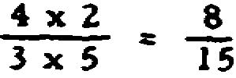
IF YOU ANSWERED THE PROBLEM CORRECTLY, SKIP TO FRAME NUMBER 72; OTHERWISE, BEGIN WITH THE NEXT FRAME.

28

 | (63)
 | To receive a product in fraction form, we have to multiply one numerator by another and one denominator by another.
 | 2/3 x 1/6 = ?
 | 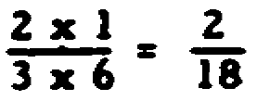
 | (64)
 | 2/18 can be reduced to _______________.
(64) | (65)
2/18 = 1/9  (2 goes into both the numerator and the denominator.) | The product of a fraction must be __________ whenever possible. 2/18 can be reduced to 1/9 by dividing the numerator and the denominator by _______________.

29

(65) | (66)
reduced, 2 | As you notice, the same number must be able to go into both the numerator and the denominator at least _________________________.
 | (number of times)
 | If both parts of the fraction can be divided by a larger number, use the largest number possible, because then you will __________ the fraction to its lowest or simplest form.
(66) | (67)
once, reduce | Now to practice.
 | 3/4 x 6/7 =
(67) | (68)
9/14 | 18/28 can be reduced by dividing ____________
 | (number)
3/4 x 6/7 = | into the numerator and the denominator.
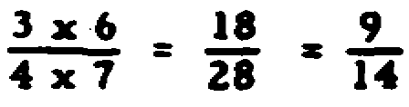

30

(68) | (69)
2 | To practice:
 | 2/3 x 6/5 =
(69) | (70)
4/5 | 7/14 x 2/8 =
2/3 x 6/5 =
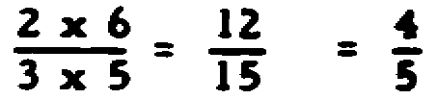
(70) | (71)
1/8 | 9/12 x 1/3 =
7/14 x 2/8 =
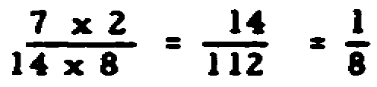

31

(71)
1/4
9/12 x 1/3 =
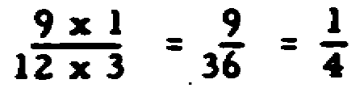

32

(72)
Very good. Now for DIVISION OF FRACTIONS.
Divide 1 3/8 by 1 1/4.
D
I
A
G F
N R
O A
S M
T E
I
C

(72)
1 1/10
1 3/8 + 1 1/4 =
11/8 + 5/4 =
11/8 x 4/5 =
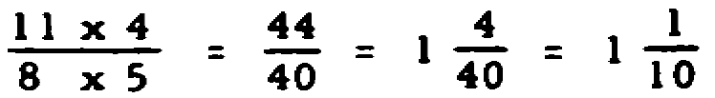
IF YOU ANSWERED THE PROBLEM CORRECTLY, SKIP TO FRAME NUMBER 83; OTHERWISE, BEGIN WITH THE NEXT FRAME.

33

 | (73)
 | When we have a problem in division, such as 1/3 ÷ 1/9 a, we first must invert the divisor. (A common error here is to go ahead and multiply before inverting the divisor.)
 | The next step is to multiply just as we did in the multiplication of fractions.
 | 1/3 ÷ 1/9 =
 | 1/3 x 9/1 =
 | 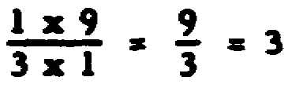
 | (74)
 | 9/3 is an example of an ___________ fraction.
(74) | (75)
improper | To practice:
 | 5/16 ÷ 3/5 = (Don't forget to invert the divisor!)

34

(75) | (76)
25/48 | 25/48 _______________ be reduced.
 | (can/cannot)
5/16 ÷ 3/5 =
5/16 x 5/3 =
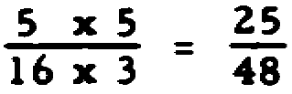
(76) | (77)
cannot | 5/8 ÷ 5/16 =
 | 2/3 ÷ 3/8 =
(77) | (78)
2, 1 7/9 | 2 1/3 ÷ 1 1/2 = ****
5/8 ÷ 5/16 =  5/8 x 16/5 =  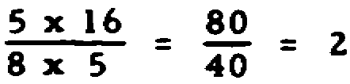 | To obtain a fraction from a mixed number, you must multiply the whole number times the denominator and then add the numerator to the product and put this sum over the original denominator as the new numerator.
 | 2 1/3 ÷ 1 1/2 =
2 1/3 ÷ 1 1/2 = | (2 x 3 = 6, 6 + 1 = 7)
2/3 x 8/3 = | (1 x 2 = 2, 2 + 1 = 3)
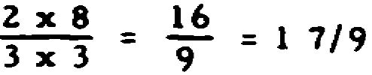 | 7/3 ÷ 3/2 =
 | 7/3 x 2/3 = 14/9 = 1 5/9

35

 | (79)
 | 6/15 + 5 1/8 =
(79) | (80)
16/205 | 5 6/7 ÷ 2 2/5 =
6/15 ÷ 5 1/8 =
6/15 ÷ 41/8 =
6/15 x 8/41 =
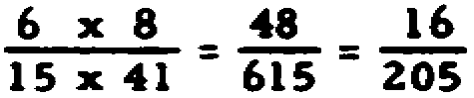
(80) | (81)
2 37/84 | 2 1/4 ÷ 3/7 =
5 6/7 ÷ 2 2/5 =
41/7 ÷ 12/5 =
41/7 x 5/12 =
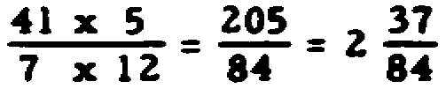
IF YOU ANSWERED THE LAST TWO (2) FRAMES CORRECTLY AND DO NOT FEEL THE NEED FOR ADDITIONAL PRACTICE, SKIP THE NEXT TWO (2) FRAMES; OTHERWISE, DO THESE TWO (2) FRAMES.
(81) | (82)
5 1/4 | 5 1/8 ÷ 6 2/7 =
2 1/4 ÷ 3/7 =
9/4 ÷ 3/7 =
9/4 x 7/3 =
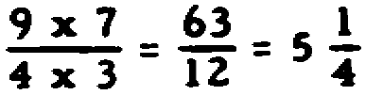

36

(82) | (83)
287/352  5 1/8 ÷ 6 2/7 =  41/8 ÷ 44/7 =  41/8 x 7/44 = | When you are asked to round off a number, you must determine whether the additional digit (which is to be dropped) is 5 or more.* If this additional digit is 5 or more, you must add 1 to the last digit that will remain in the answer; if this additional digit is 4 or less, the last digit remains unchanged.
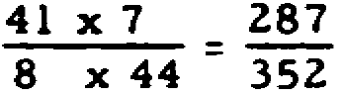 | For example:
 | a. .7787 (round off to three (3) decimal places)
 | Answer: .779. Since 7 is more than 4, 1 is added to 8 to make 9.
 | b. .7897 (round off to three (3) decimal places)
 | Answer: .790. Since 7 is more than 4, 1 is added to 9 to make 10 and the 1 is carried over to the next digit, 8, to make 9.
 | c. .7443 (round off to three (3) decimal places)
 | Answer: .744. Since the 3 is less than 5, the last digit, 4, will remain unchanged.
 | *"Rounding-Off" of decimals - remember, even though you must work out problems to the highest number of places any element in the problem contains, your answer may be accurate only to the degree of accuracy of your meter. If your meter will measure only to one tenth or one hundredth then your answer with five or six figures to the right of the decimal would not be measurable, and the answer should be rounded off.

37

 | (84)
 | Now let's practice.
 | a. .84364 (round off to four (4) decimal places). Answer: _______________________
 | b. .32245 (round off to four (4) decimal places). Answer: _______________________
(84) | (85)
a. .8436  b. .3225 | You must be able TO CONVERT COMMON FRACTIONS TO DECIMAL FRACTIONS. To convert, divide the numerator by denominator to receive the decimal results. For example:
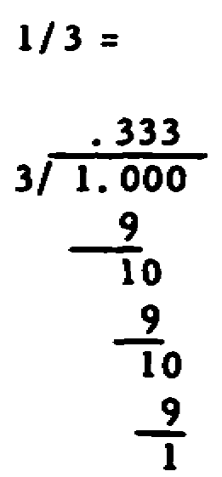
Place a decimal point after the units digit of the numerator and add one zero to secure the decimal quotient expressed in tenths (2 zeros for the decimal quotient in hundredths and 3 zeros for the decimal quotient in thousandths).

38

 | (86)
 | 7/8 = __________________________________
 | (Convert to a decimal fraction)
(86) | (87)
.875 | 3/4 = __________________________________
 | (decimal fraction)
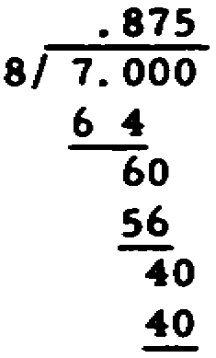
(87) | (88)
.75 | 5/8 = __________________________________
 | (decimal fraction)
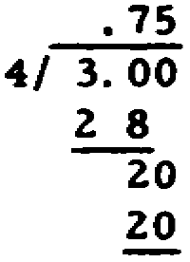

39

(88) | (89)
.625 | 72/80 = ****
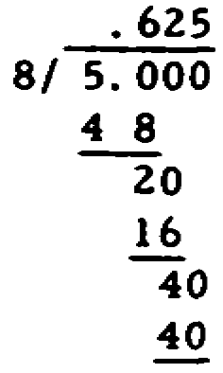 | A short cut to converting a fraction to a decimal when possible, is to reduce the fraction and then divide to find the decimal value.  72/80 = 9/10  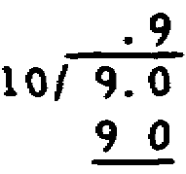
 | (90)
 | 4/26 = __________________________________
 | (Round off to three decimal places)
(90) | (91)
.154 | 9/270 = _________________________________
 | (Round off to two decimal places)
4/26 = 2/13
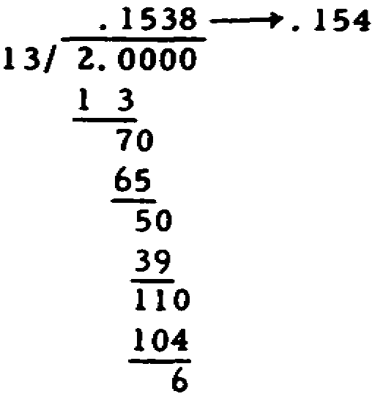

40

DECIMALS
(91) | (92)
.03 | Fine, now let's try ADDITION OF DECIMALS.
9/270 = 1/30 | When the numbers containing the decimals are lined up, the problem should look like this -
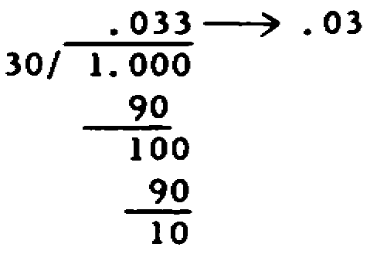 | 6.89
 | +.357
 | The next problem is to see if the top quantity has the same number of digits to the right of the decimal point as the second or bottom quantity has. If there is a difference, a zero is added or placed for each digit needed.
 | Remember placing zeros after a decimal point (to the right) does not change the value. In this problem a zero is added or placed after the "9" to make the addition easier by lining up vertical columns.
 | 6.890
 | +.357

41

 | (93)
 | Now let's add.
 | 2.063 + .0026 = (Hint: Convert to vertical form before adding.)
(93) | (94)
2.0656 | 0.135 + 0.435 + 2.31 + 0.0012 + 0.9 =
2.063 + .0026 =
2.0630 Add zero
+ .0026
2.0656

42

(94) | (95)
3.7812
0.1350 | 1.416 + 0.1 + 0.0001 + 3.2865 + 1.4 =
0.4350
2.3100
0.0012
0.9000
3.7812
(95) | (96)
6.2026
1.4160 | Now let's subtract.
0.1000
0.0001 | 14.7500
3.2865 | - .0036
1.4000
6.2026

43

(96) | (97)
14.7464  14.7500  - .0036  14.7464 | Zeros can be eliminated from the answer when they are to the right of the decimal point and are not followed by any other digit. Thus, 54.7500, in final form, would read 54.75. Remember zeros to the right of the decimal when not followed by any other digits do not change the _______________ of the quantity.
(97) | (98)
value | Thus 50.0020, in final form, would read _______________.
 | 4.0200, in final form, would read ___________.
(98) | (99)
50.002, 4.02 | 41.75 - 2.63 =
(99)
Note borrowing of 10 from 4.
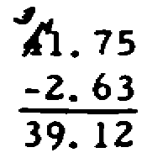

44

D  I  A  G F  N R  O A  S M  T E  I  C | (100)
D  I  A  G F  N R  O A  S M  T E  I  C | Now let's multiply
D  I  A  G F  N R  O A  S M  T E  I  C | 3.003 x 4.05=
(100)
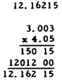
IF YOU ANSWERED THE PROBLEM CORRECTLY AND DO NOT THINK THAT YOU NEED ANY ADDITIONAL PRACTICE, SKIP TO FRAME NUMBER 104; OTHERWISE, START WITH THE NEXT FRAME.

45

 | (101)
 | 3.14 x 3.285
 | Remember when multiplying numbers containing decimals, count the number of digits to the right of the decimal point in each of the multipliers, add these, and place the decimal point in the product so that an equal number of digits are to its right. For example, in this problem, the first multiplier has two digits to the right of the decimal, the second multiplier has three, and the product must then have five.
(101) | (102)
10.3149 | 1.123 x 0.013 =
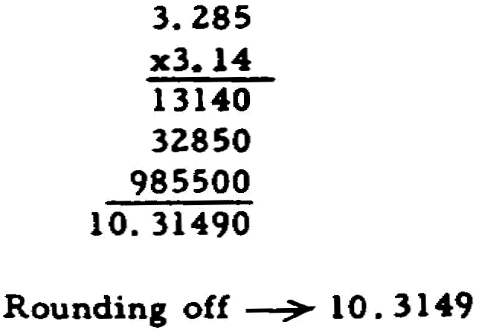

46

(102) | (103)
.014599 | 23.08 x 11 =
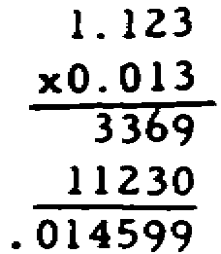
(103)
253.88
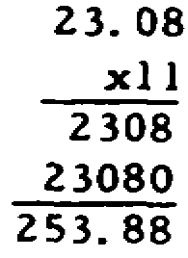

47

D  I  A  G F  N R  O A  S M  T E  I  C | (104)
D  I  A  G F  N R  O A  S M  T E  I  C | Good job. Now let's divide.
D  I  A  G F  N R  O A  S M  T E  I  C | Divide 10.284 by 0.261
D  I  A  G F  N R  O A  S M  T E  I  C | (round off to two (2) places beyond the decimal point).

48

(104)
39.40
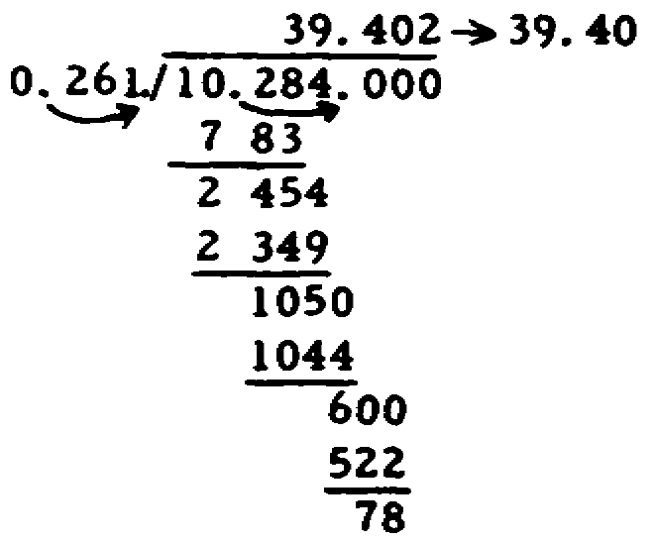
IF YOU ANSWERED THE PROBLEM CORRECTLY, AND FEEL YOU DO NOT NEED ADDITIONAL PRACTICE, SKIP TO NUMBER 116; IF YOU ONLY MISSED THE PROBLEM BECAUSE OF INCORRECT ROUNDING OFF, SKIP TO FRAME NUMBER 108; OTHERWISE, BEGIN BY DOING THE NEXT FRAME.

49

(105)
When your divisor contains decimals, count the number of places in the divisor to the right of the decimal point and move the decimal to the right that number of places to make the divisor a whole number.
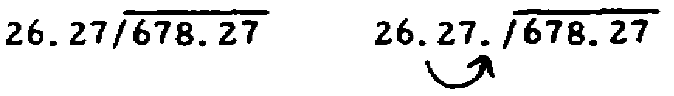
If the dividend already contains a decimal, move the decimal to the right the same number of places as moved in the divisor (adding zeros if necessary).
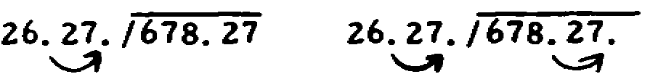
Then, place a decimal point in the quotient immediately above the new decimal place in the dividend.
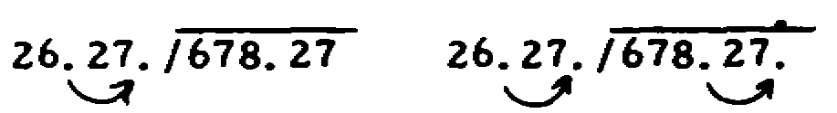
(106)
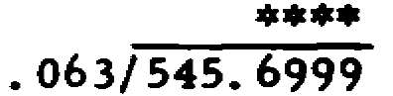
Before dividing, you must make the divisor a whole number by moving the decimal point as far to the right as is needed; also, you must move the decimal point in the dividend the same number of digits to the right as was done in the divisor. Following the above instructions, the above problem would be as follows:
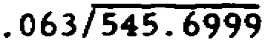
(move decimals)

50

(106) | (107)
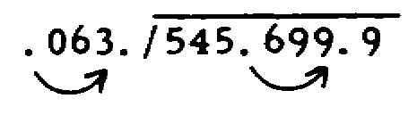 | 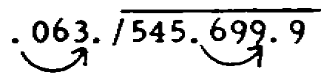
 | Now divide the above problem. Don't worry if a remainder may appear.
(107) | (108)
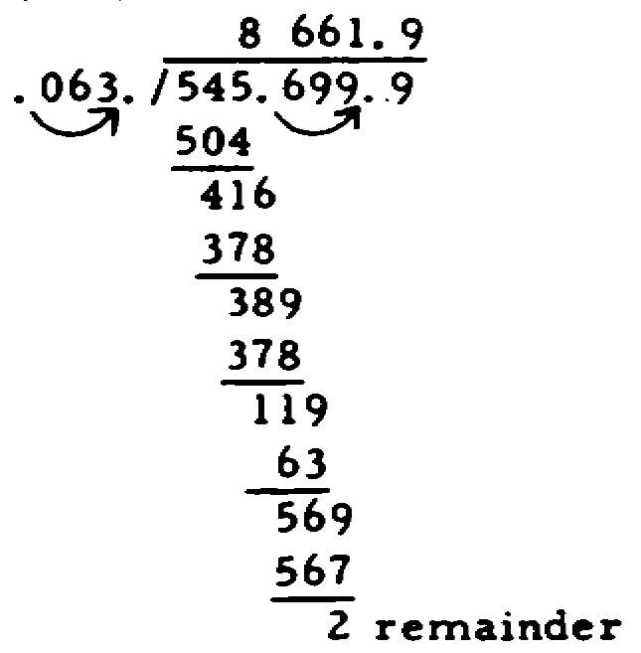 | To practice:  25.75 ÷.05 =

51

(108) | (109)
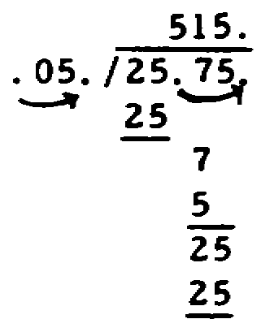 | 327.66 ÷ .00023 =  (Disregard the remainder.)

52

(109) | (110)
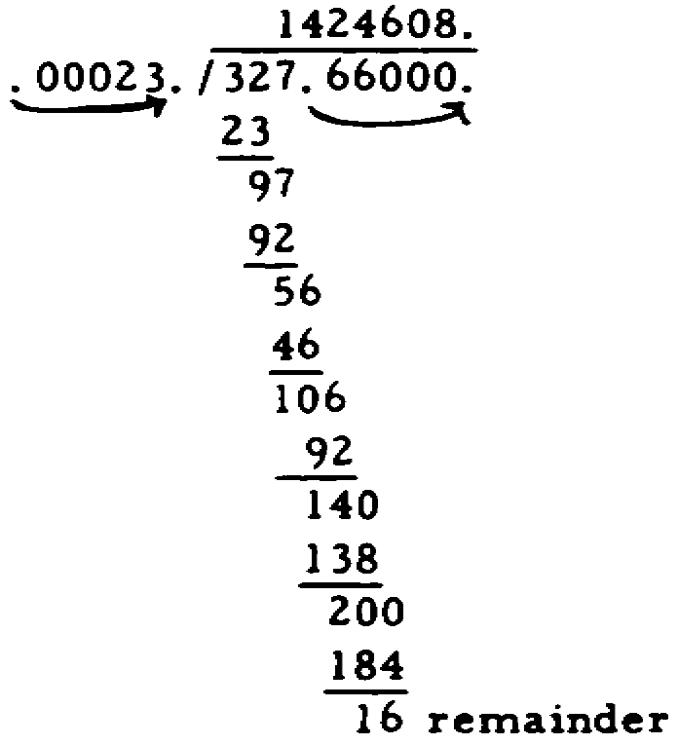 | 1.1732 ÷ 1.31 = (Carry the quotient or answer out to six (6) places and then round off to five places.)

53

(110) | (111)
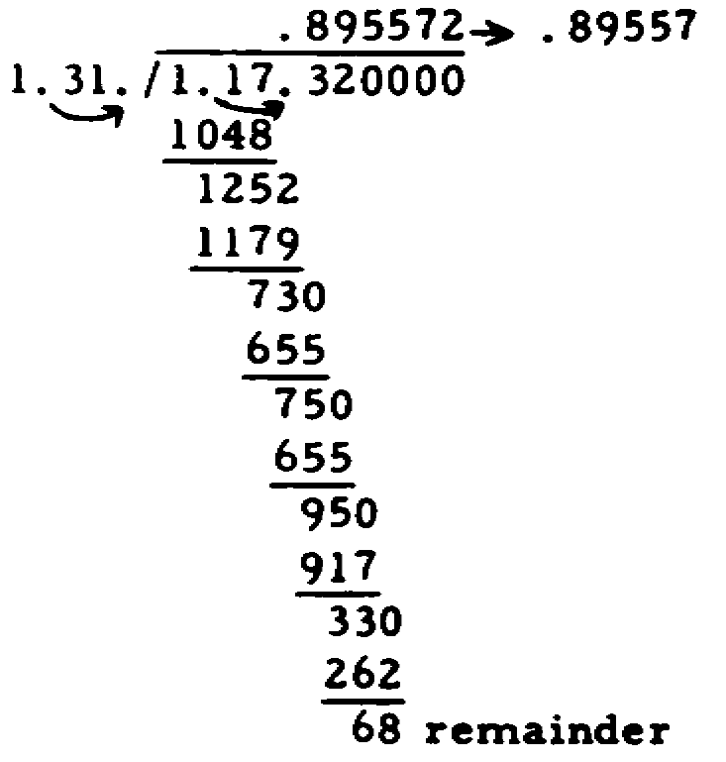 | 0.0248 ÷ 0.0113 =  (Carry out to four (4) places beyond the decimal point and then round off to three places.)
(111) | (112)
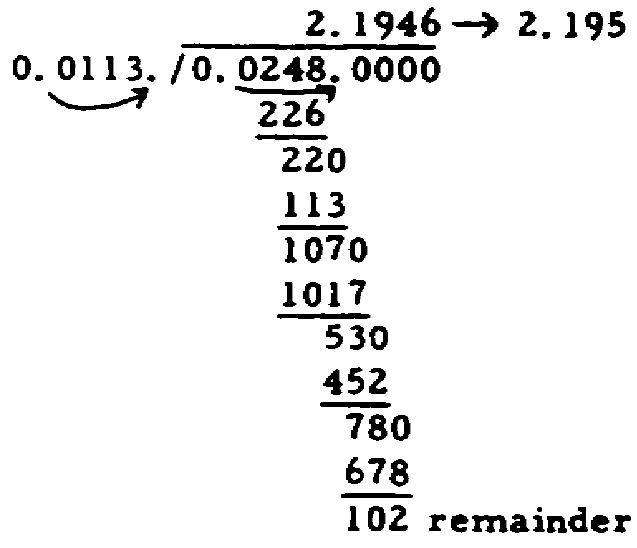 | If you have a dividend which does not contain a decimal, place a decimal point after the whole number, and then move the decimal the number of places that you moved the decimal point in the divisor. For example:  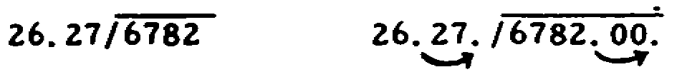

54

 | (113)
 | 485 ÷ 1.638 = (Carry out to two (2) places beyond the decimal point and then round off to one place.)
(113) | (114)
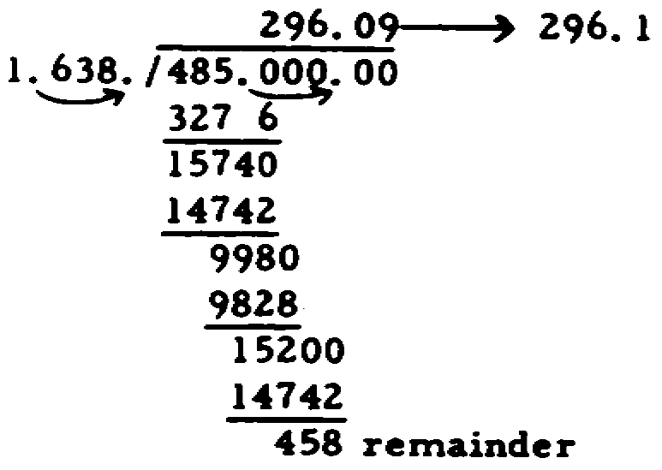 | 546 ÷ 0.91 =
(114) | (115)
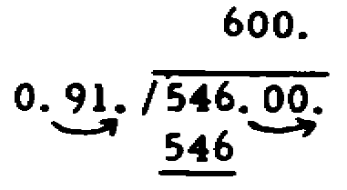 | 4.96 ÷ 62 =
(115)
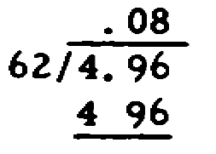
When the divisor is not a decimal, you do not have to move the decimal point before dividing.

55

 | METRIC PREFIXES
 | (116)
 | Well done. Let's try the METRIC PREFIXES. Before proceeding further, please pull out your METRIC DATA CONVERSION SHEET at the rear of this text. You will need it to work problems dealing with the METRIC PREFIXES.
 | At the top of the sheet, you will find several columns (entitled PREFIXES, SYMBOLS, VALUES, and ASSOCIATED WITH). To determine the symbol for a prefix (having found the prefix), you must look straight across to the SYMBOLS column and you will find the symbol.
 | The symbol for the prefix mega is M.
 | (117)
 | The symbol for the prefix kilo is _____.
(117) | (118)
K | The symbol for micro-micro is _____.
(118) | (119)
uu | Milli has the symbol of _____.
IF YOU FEEL YOU DO NOT NEED MORE PRACTICE SKIP THE NEXT TWO (2) FRAMES; OTHERWISE, DO THE NEXT TWO (2) FRAMES.

56

(119) | (120)
m | Micro has the symbol _____.
(120) | (121)
u | A metric prefix can be replaced by a symbol. The symbol "M" is used for _____.
(121) | (122)
mega | "K" is used for _____.
(122) | (123)
kilo | "u" is used for __________.
(123) | (124)
micro | To determine the value of a prefix, use the PREFIXES column and the VALUES column. Remember to look straight across the sheet.
 | Micro-micro or pico has a value of one trillionth.

57

 | (125)
 | The value of the metric prefix mega is ______.
(125) | (126)
one million | Kilo has a value of a __________.
(126) | (127)
thousand | One thousandth is the value of the prefix ________.
IF YOU FEEL YOU DO NOT NEED MORE PRACTICE, SKIP THE NEXT TWO (2) FRAMES; OTHERWISE, DO THE NEXT TWO (2) FRAMES.
(127) | (128)
milli | Micro's value is _____ __________.

58

(128) | (129)
one millionth | You should be familiar with how the prefixes are commonly used. To determine this, use the PREFIXES column and the ASSOCIATED WITH column. Again remember to look straight across the sheet. DO NOT USE THE "CONVERSION FACTORS" TABLE FOR THESE PROBLEMS.
 | Mega is associated with ohms and cycles.
 | (130)
 | Micro-micro is ASSOCIATED WITH __________.
(130) | (131)
farads | Volts is ASSOCIATED WITH three (3) metric prefixes: micro, kilo, and __________.
(131) | (132)
milli | Watts is ASSOCIATED WITH the metric prefixes, _____, _____ , and _____.

59

(132) | (133)
kilo, milli, micro. | Amps is ASSOCIATED WITH the metric prefixes _____ and _____.
(133) | (134)
milli, micro | Henries is ASSOCIATED WITH the metric prefixes _____ and _____.
(134) | (135)
milli, micro | Mega is ASSOCIATED WITH o_____ and c_____
(135) | (136)
ohms, cycles | Milli is ASSOCIATED WITH v , a , w , and h .

60

(136) | (137)
volts, amps, watts, henries | Micro is ASSOCIATED WITH v , a , h , and f .
(137) | (138)
volts, amps, henries, farads | Kilo is ASSOCIATED WITH v , o , c , and w .
(138) | (139)
volts, ohms, cycles, watts | Farads alone is ASSOCIATED WITH the prefix _____ or _____.
(139) | (140)
micro-micro, or pico | One should memorize the metric prefixes, because the METRIC DATA CONVERSION SHEET may not always be available.
 | The metric prefixes should be _____.
(140) | (141)
memorized | The METRIC DATA CONVERSION SHEET may not always be available. One should __________ the metric prefixes.

61

(141) | (142)
memorize | Good. Let's convert factors. Under the heading CONVERSION FACTORS, there are four columns - GIVEN, TO OBTAIN, MULT. BY, and DIVIDE BY. In your problems you will be given a factor (first column), then you will be told to obtain another factor (use column #2) and lastly, you will determine whether to multiply or divide and by what figure (third or fourth columns). Remember to look straight across the sheet.
 | For instance, given 2 amperes and told to obtain milliamperes, you would multiply 2 times 1,000 to arrive at an answer of 2,000 milliamperes.
 | (143)
 | If you have 2,000,000 cycles and you convert it to megacycles, you will have _____ megacycles.
(143) | (144)
2 | When you have to change volts to millivolts, you have to multiply by __________.
2,000,000 ÷ 1,000,000 = 2

62

(144) | (145)
1,000 | If you change .0000003 farads to microfarads, you have __________ microfarads.
(146) | (146)
.3  1,000,000 x .0000003 =  .3000000 = .3 | 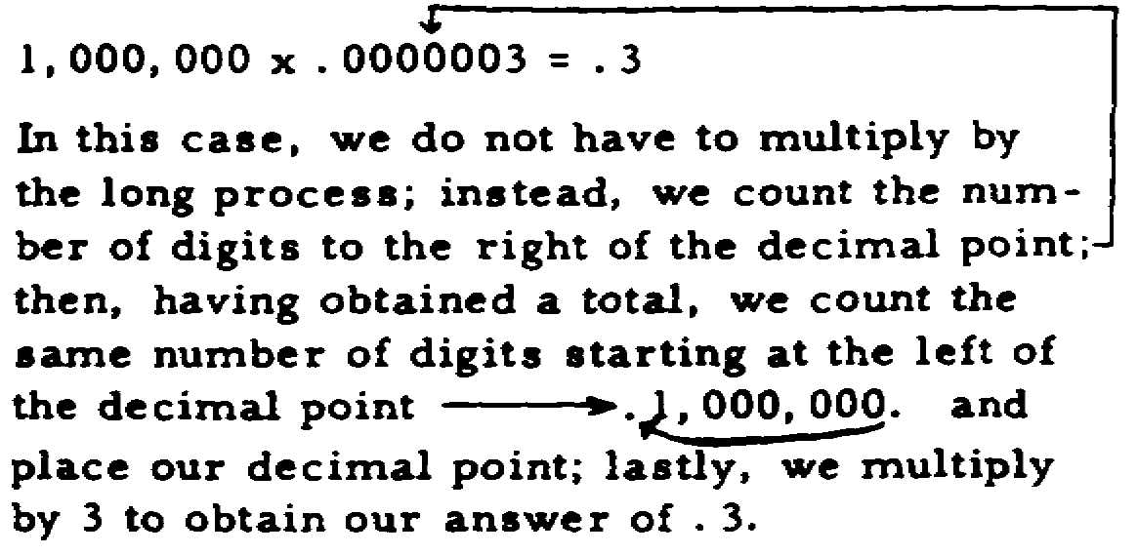
 | (147)
 | 1 farad equals __________ microfarads.
(147) | (148)
1,000,000 | 63 milliamperes will give us _____ amperes.
1,000,000 x 1 =
1,000,000

63

(148) | (149)
.063 | To convert kilovolts to volts we must __________ by 1,000.
63 ÷ 1,000 = .063
Actually we did not multiply by the long process. We count the number of zeros in 1,000 (which is 3) and we move the decimal point three (3) places to obtain our answer.
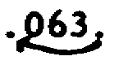
IF YOU FEEL YOU DO NOT NEED ADDITIONAL PRAC-TICE, SKIP TO FRAME NUMBER 153; OTHERWISE, DO THE NEXT FOUR (4) FRAMES.
(149) | (150)
multiply | If you have 9,720,000 cycles per seconds and you convert it to megacycles, you have __________ megacycles.

64

(150) | (151)
9.72 | .05 microfarads equals __________ micro-micro farads.
9,720,000 ÷ 1,000,000
9,720,000 ÷ 1,000,000 =
9.72
(151) | (152)
50,000 | .004 amperes will give us _____ milliamperes.
.05 x 1,000,000 =
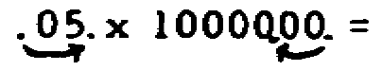
5 x 10,000 = 50,000
(152)
4
.004 x 1,000 =
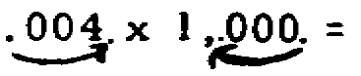
4 x 1 = 4

65

 | SQUARE ROOT
D  I  A  G F  N R  O A  S M  T E  I  C | (153)
D  I  A  G F  N R  O A  S M  T E  I  C | Very good. Now let's try SQUARE ROOT.
D  I  A  G F  N R  O A  S M  T E  I  C | If you do not know how to calculate square root, please turn to frame Number 164 before attempting to work a problem. When you finish frame number 164, begin with frame number 154.
D  I  A  G F  N R  O A  S M  T E  I  C | Problem:
D  I  A  G F  N R  O A  S M  T E  I  C | Find the square root of 130. (Carry the root to three (3) places beyond the decimal point and round off to two places.)
(153)
11.40
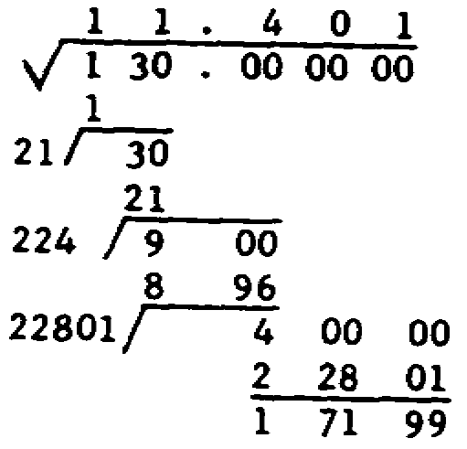
IF YOU ANSWERED THE PROBLEM CORRECTLY AND FEEL YOU DO NOT NEED ADDITIONAL PRACTICE, YOU MAY NOW TAKE THE QUIZ (PAGE 81); OTHERWISE, BEGIN WITH THE NEXT FRAME.

66

 | (154)
 | Do as directed.
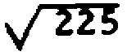
Separate the radicand into the necessary groups.
(154) | (155)
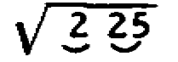 | 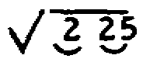  Determine the number which when multiplied by itself (squared) will give you a product equal to the first digit group under the radical sign. If you cannot find a number which when multiplied by itself (squared) equals digit group under the radical sign, select the number which when squared is closest to (and smaller than) the digit group.
(155) | (156)
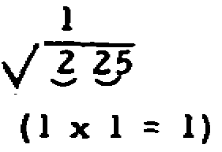 | 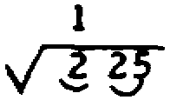  Place the product of the number multiplied by itself below the group, subtract any difference, and bring this difference down. Then bring the next group down.
(156) | (157)
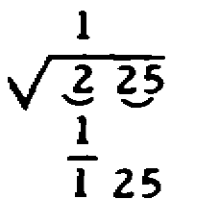 | 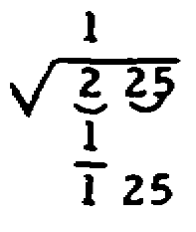  Double the trial square root (above the radical sign) and place it to the left of the difference obtained, allowing room for another digit.

67

(157) | (158)
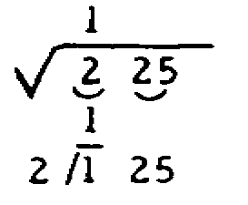 | 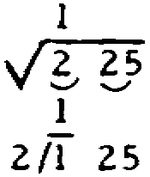  Find the next digit of this divisor, which is the next digit of the root. Use a number which will enable the divisor when multiplied by the selected number to approximate the radicand; place this digit to the right of the divisor and the same digit below itself. Place it in the root above the appropriate group of the radicand.
(158) | (159)
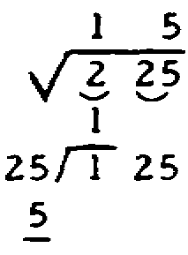 | 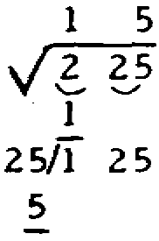  Multiply the divisor by the new portion of the root, and place this product under the appropriate radicand.
(159) | (160)
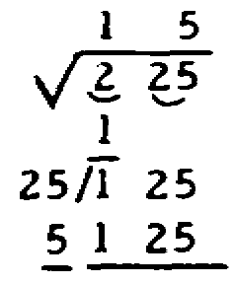 | Good. Now to practice:  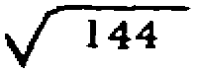
There is no remainder.

68

(160) | (161)
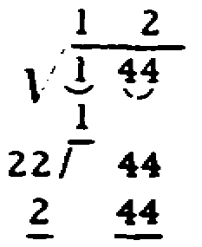 | When we find the square root of 225, which is 15, we can make sure that the answer is correct by multiplying 15 x 15. In this case, we did the problem correctly because 15 x 15 = 225.  12 is a number which, when multiplied by itself, gives us the original number _________.
(161) | (162)
144 | To practice:
 | 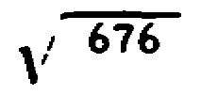
(162) | (163)
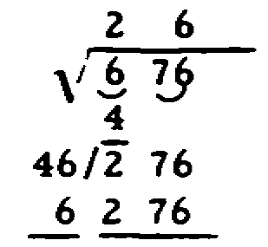 | 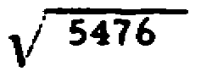

69

(163) | (164)
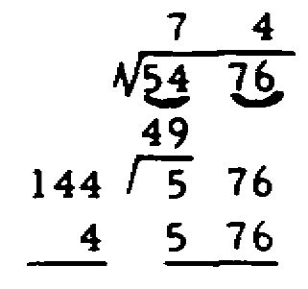 | To calculate square root, you must do the following:  (1a) Starting at the right (units column) of the quantity, separate the radicand (portion under the square root sign) into groups of two (2) digits.
 | 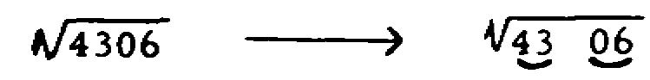
IF YOU FEEL YOU HAVE MASTERED THE SQUARE ROOT PROBLEMS SO FAR, DO FRAMES 165-167; IF YOU FEEL YOU HAVE NOT MASTERED SQUARE ROOT, DO THE REMAINING FRAMES.
 | (1b) (If the quantity contains a decimal)
 | From the right of the decimal point, separate this portion of the radicand into groups of two (2) digits each.
 | 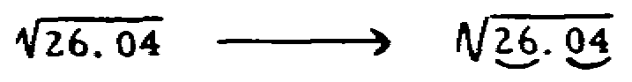
 | (1c) If the radicand does not contain an even number of digits to divide into groups, the remaining single number is treated the same as a group.
 | 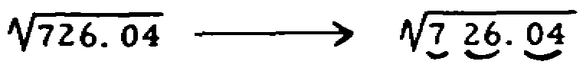
 | (2) Place a decimal point directly above the decimal point in the radicand
 | 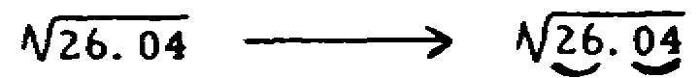

70

(3) Determine what number when multiplied by itself will approximate or equal the first group (or single digit) under the radical sign, and then place that number directly above the second digit of that group. For Example:
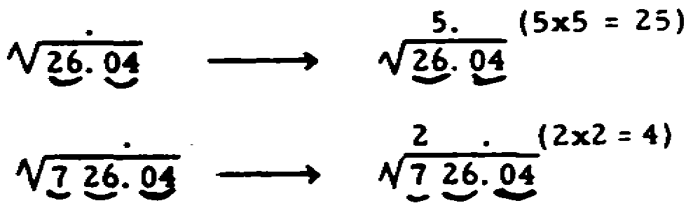
(4) Place the product of the number multiplied by itself below the group, subtract any difference, and bring this difference down.
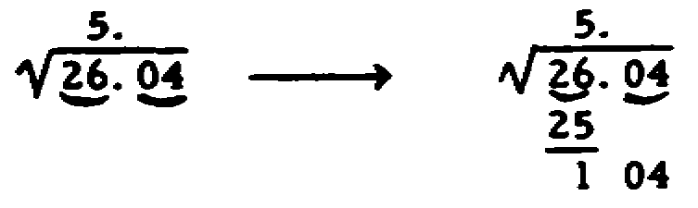
(5) Double the trial square root (above the radical sign) and place it to the left of the difference obtained, allowing room for another digit. This is your divisor.
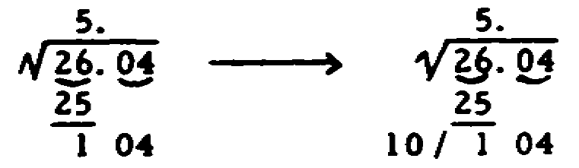

71

(6) Find the next digit of this divisor, which is the next digit of the root. Use a number which will enable the divisor and the root when multiplied to approximate the new radicand; place this digit to the right of the divisor and the same digit below itself. Place it in the root above the digit of the appropriate group of the radicand.
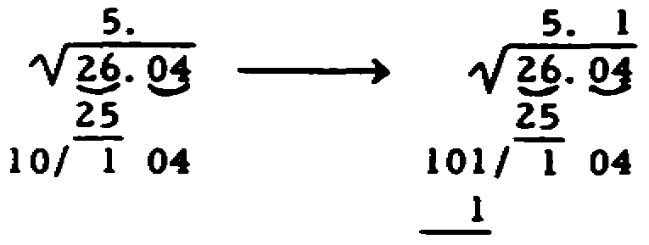
(7) Multiply the divisor by the new portion of the root, and place this product under the appropriate radicand, subtract any remainder, and bring down the next group (if there is one) and repeat the operations in frames 5, 6, and 7. If the remainder (with an additional group of two zeros) is too small to permit the new divisor to be divided into it, carry the original remainder as a remainder.
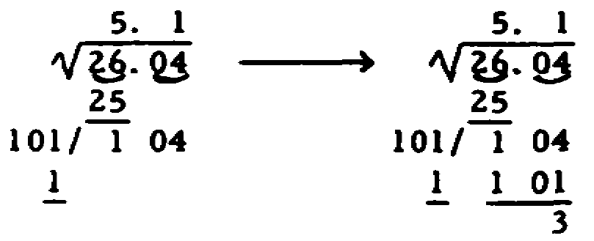
The square root is 5.1 with a remainder of 3.

72

 | (165)
 | To practice:
 | 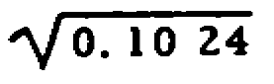
(165) | (166)
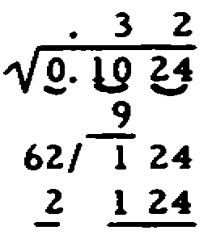 | 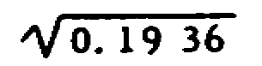
(166) | (167)
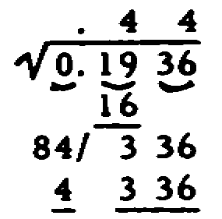 | 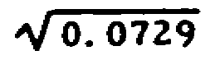

73

(167)
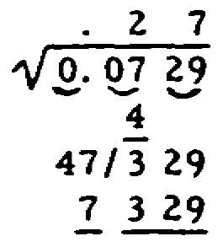
IF THERE IS ANY BASIC MATH AREA STILL NOT CLEAR TO YOU, REVIEW THAT AREA; OTHERWISE, YOU MAY TAKE THE QUIZ (PAGE 80)

74

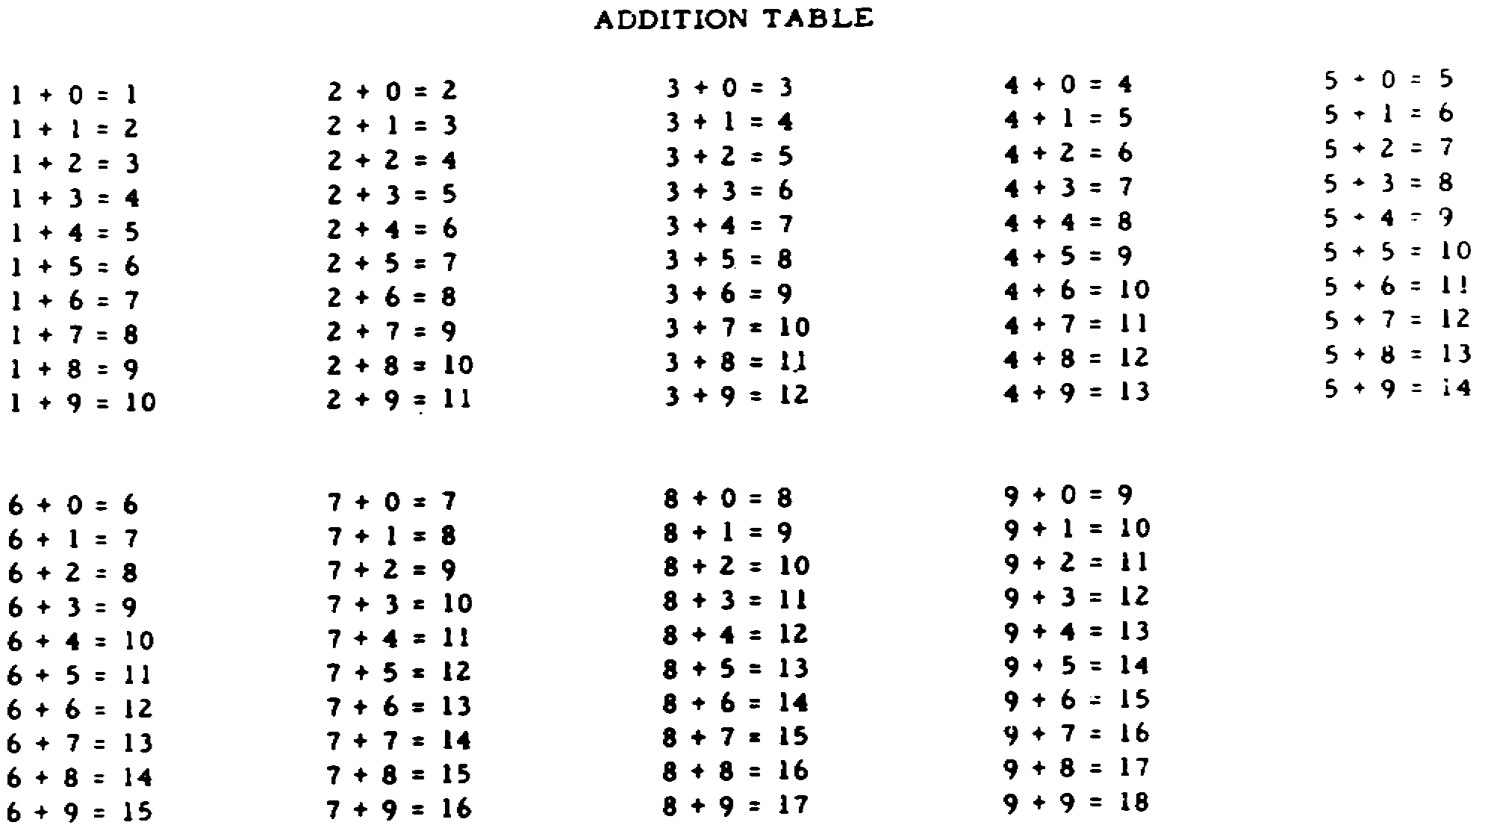

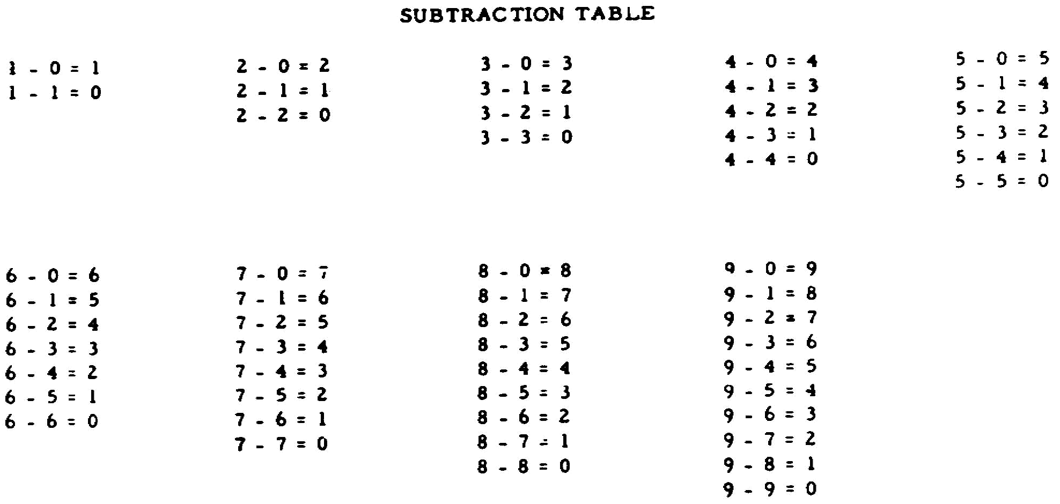

75

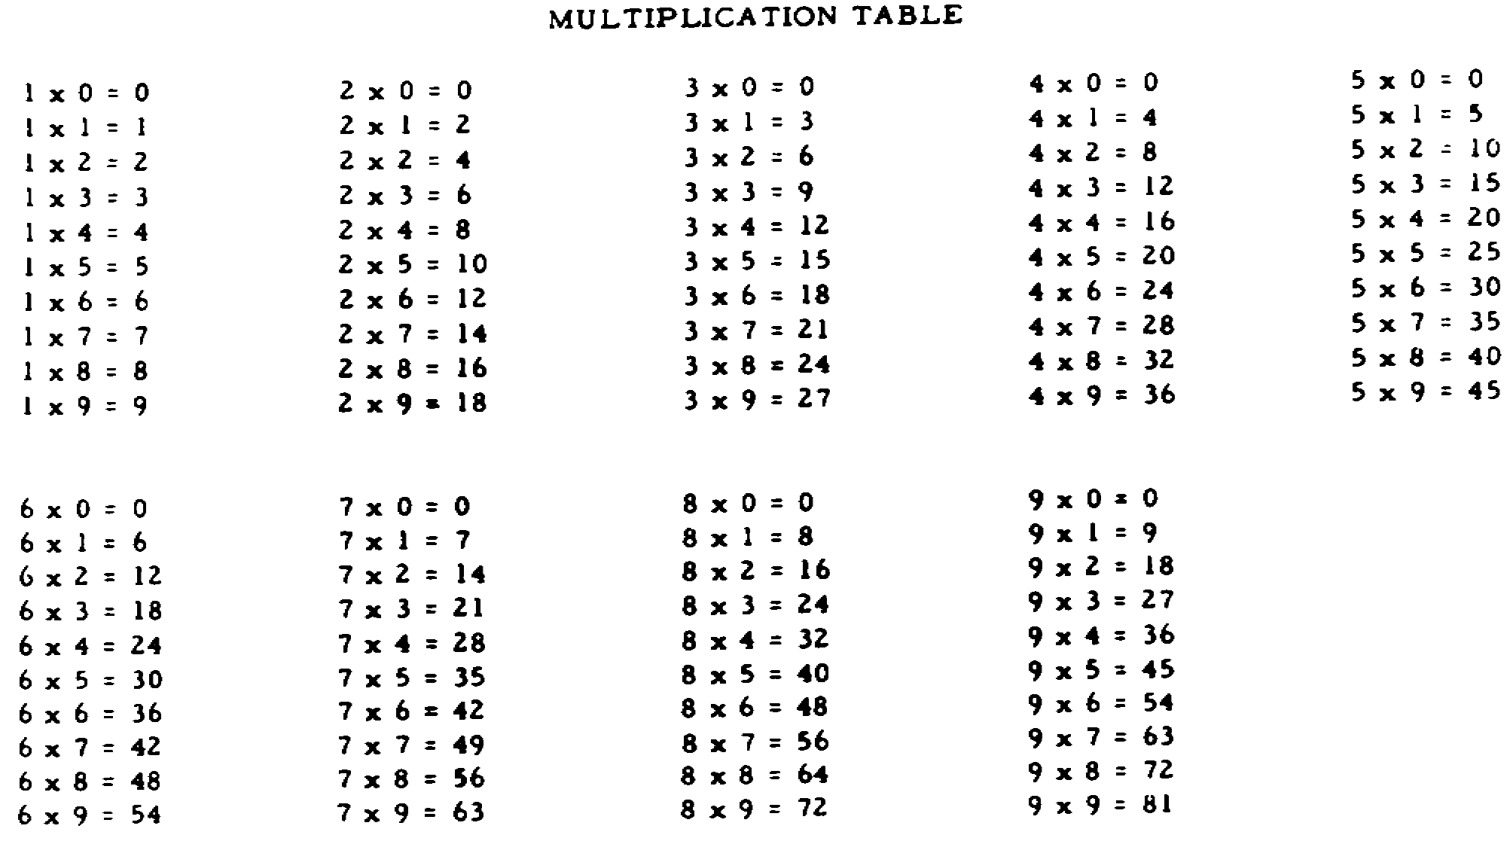

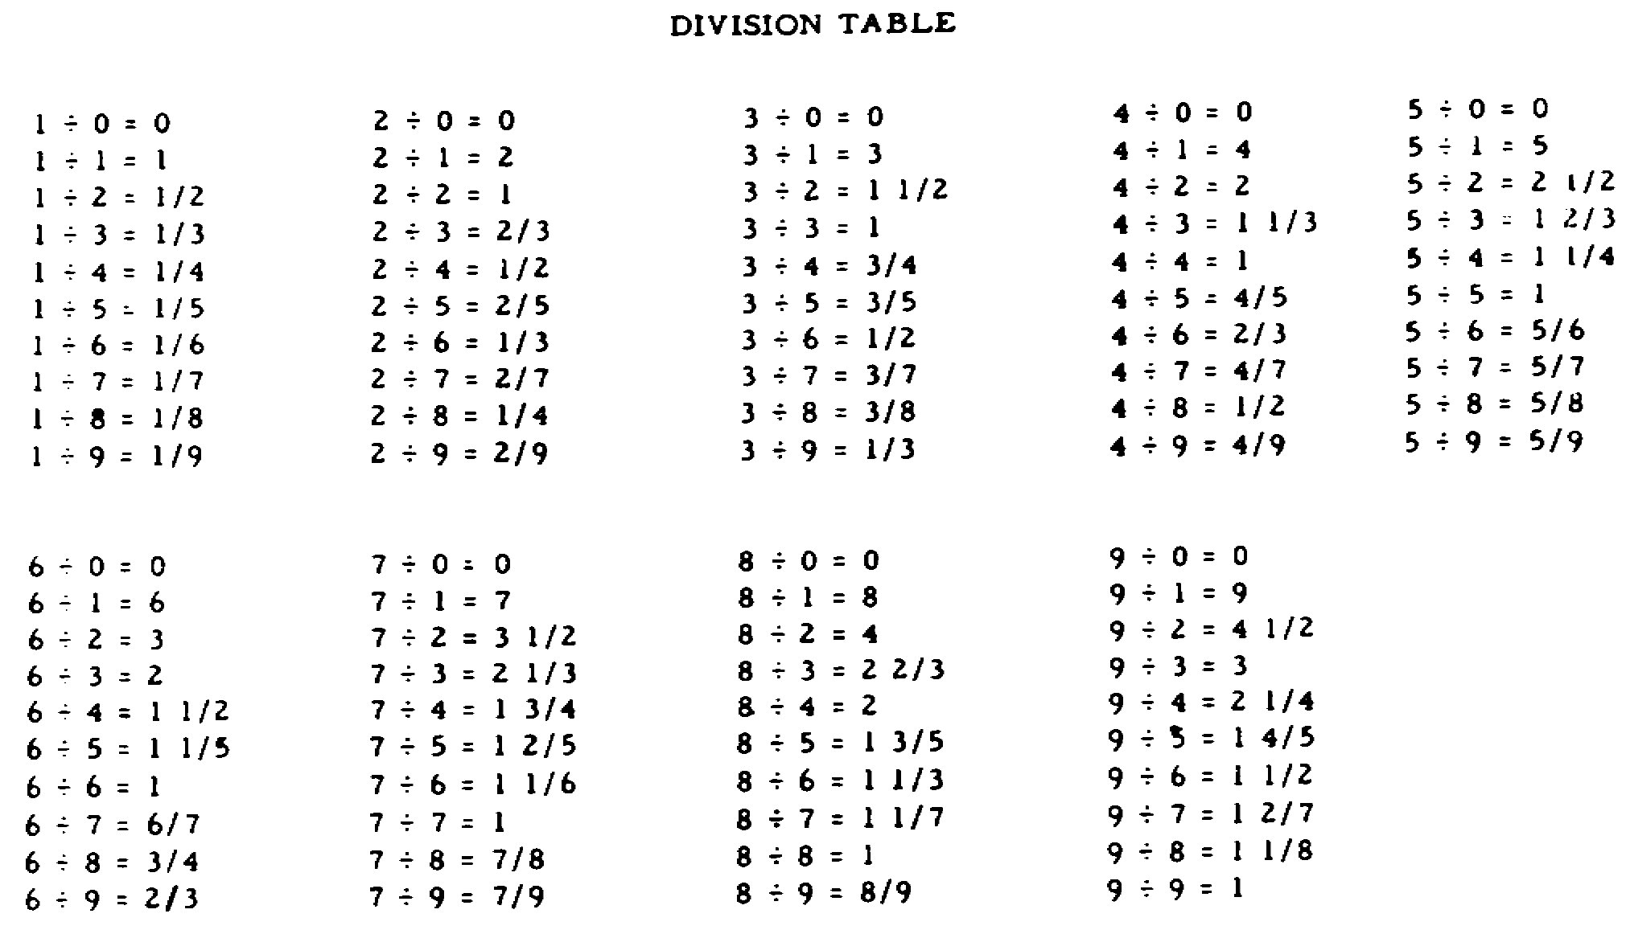

76

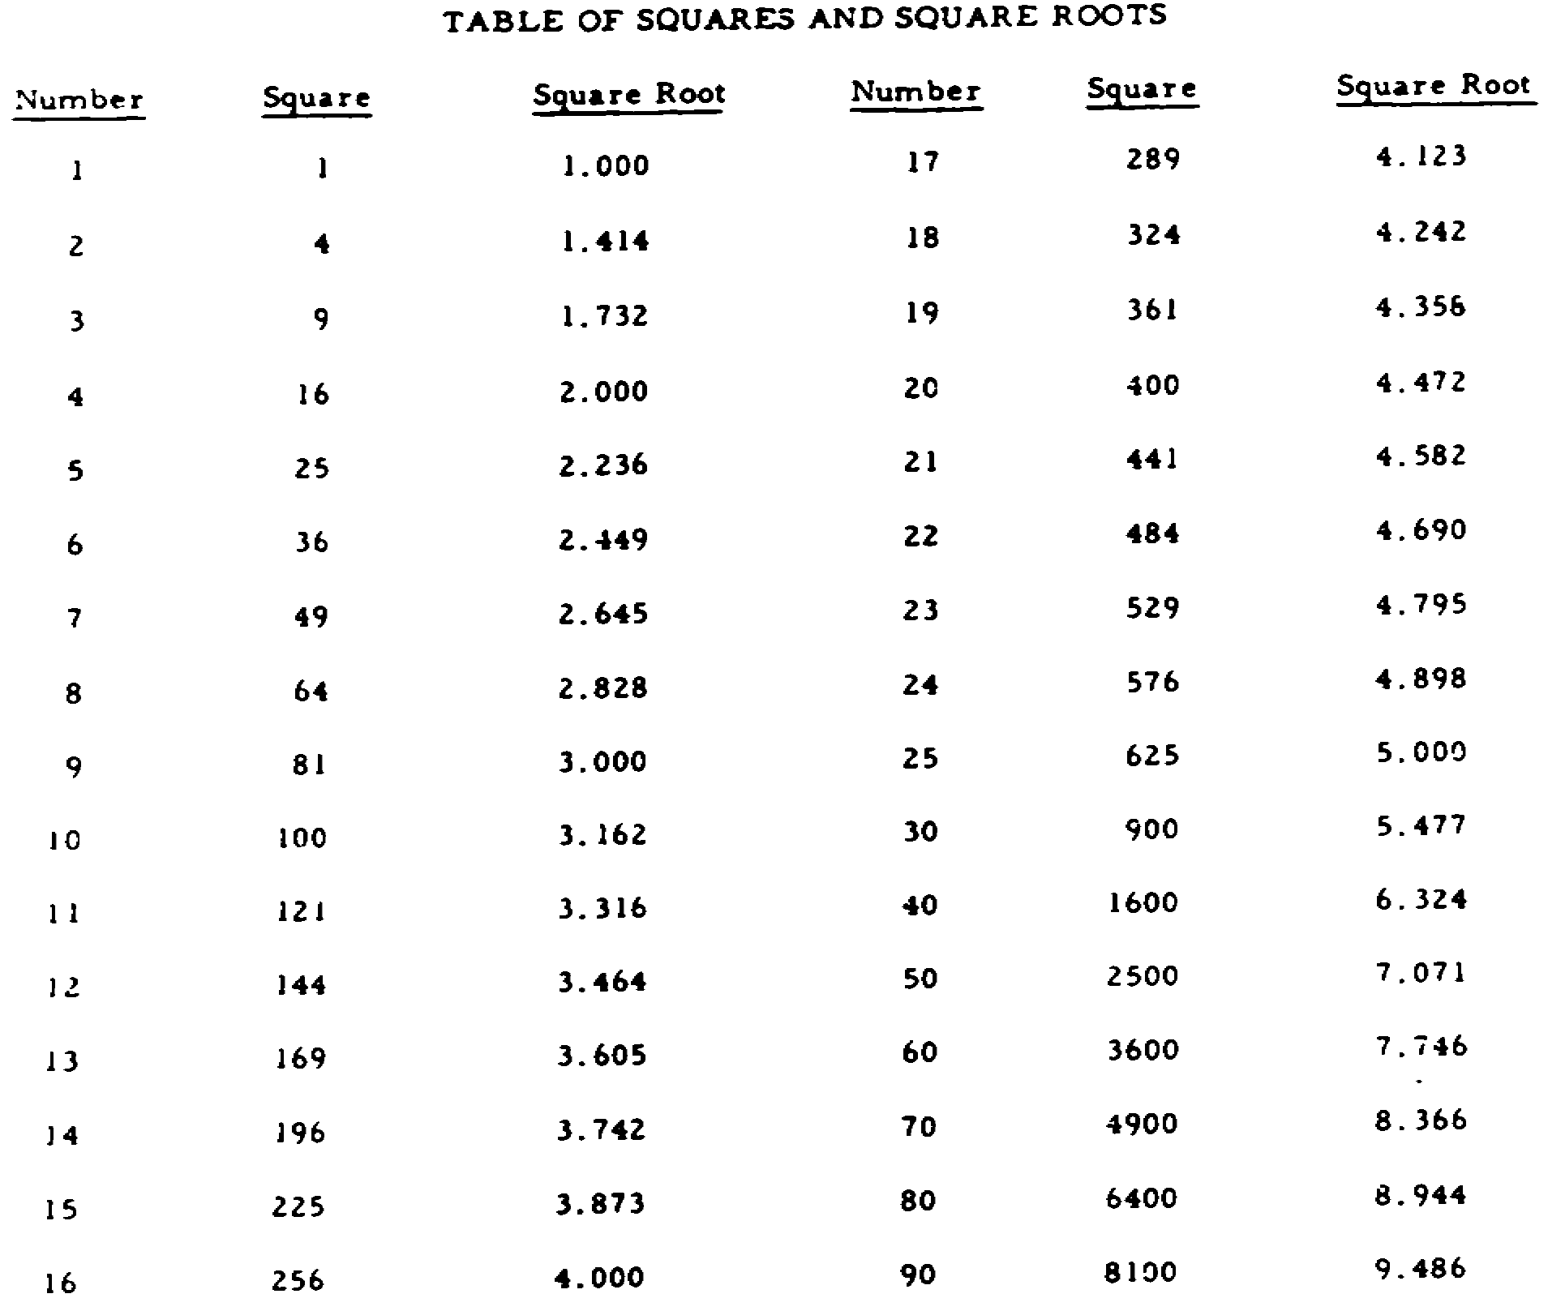

77

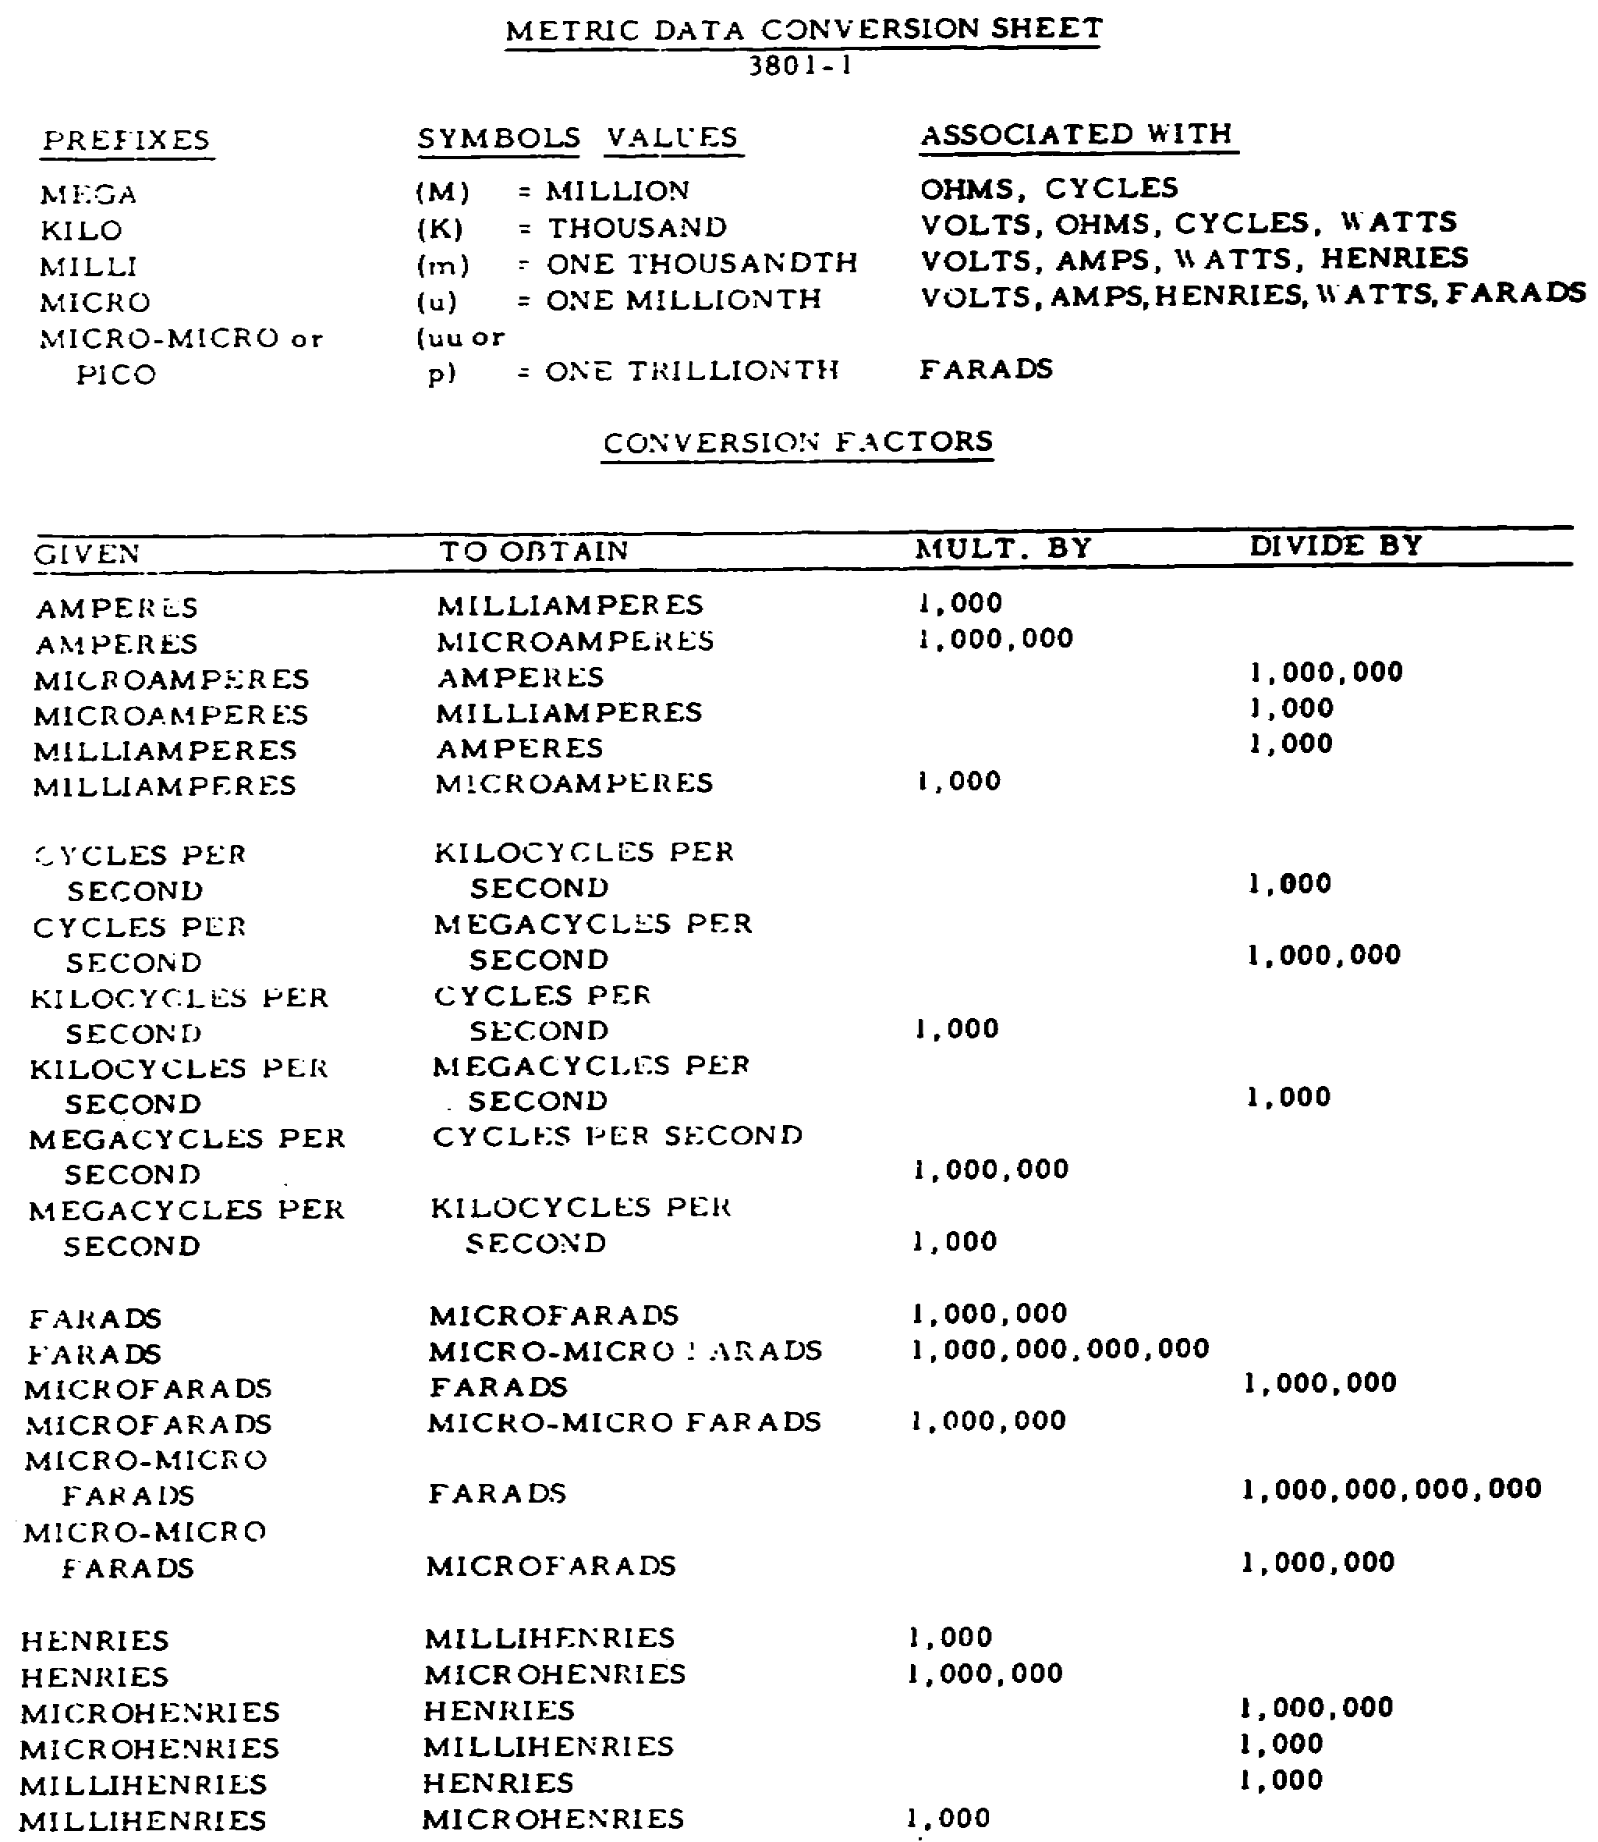

78

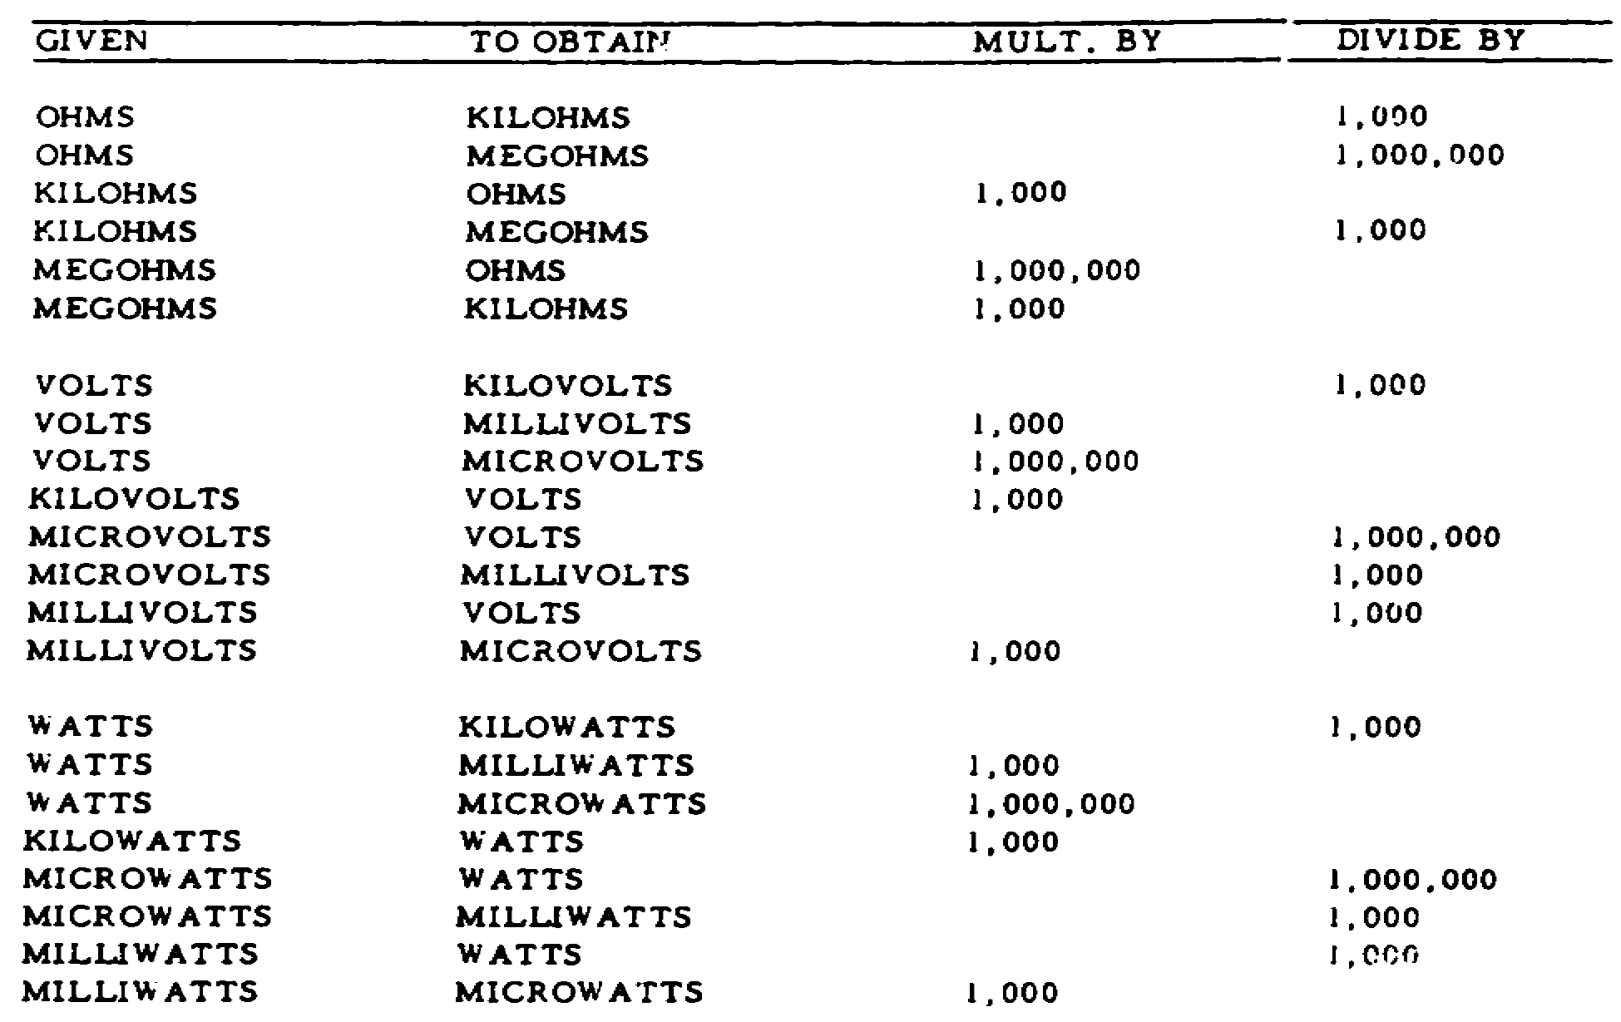

79

SELF QUIZ

1.
Add 1/5, 1/7, 2/3, and
4/9.

2.
Subtract 1/3 from 5/7.

80

3.
Multiply 2/5 times 9/4.

4.
Divide 1 2/3 by 2/9.

81

5.
0.245
3.21
0.534
0.0031
0.90

6.
0.44
-0.0028

82

7.
1.004
x5.03

8.
Divide 0.0248 by 0.0113
(round off to two places
beyond the decimal
point).

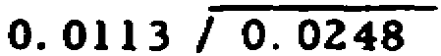

83

9. What is the value of kilo? ___________________________________________

10. What metric prefix does the symbol "m" stand for? ____________________

11. Convert 2 microhenries to henries.

84

12. Find the square root of 150 correct to the second decimal (round off).

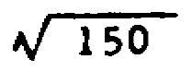

NOW CHECK YOUR ANSWERS TO THE QUIZ (PGS. 86, 87, AND 88) AND SEE HOW WELL YOU HAVE DONE. ONE MISTAKE IS CONSIDERED EXCELLENT. REVIEW ANY BASIC MATH AREA STILL NOT CLEAR TO YOU.

85

ANSWERS TO QUIZ

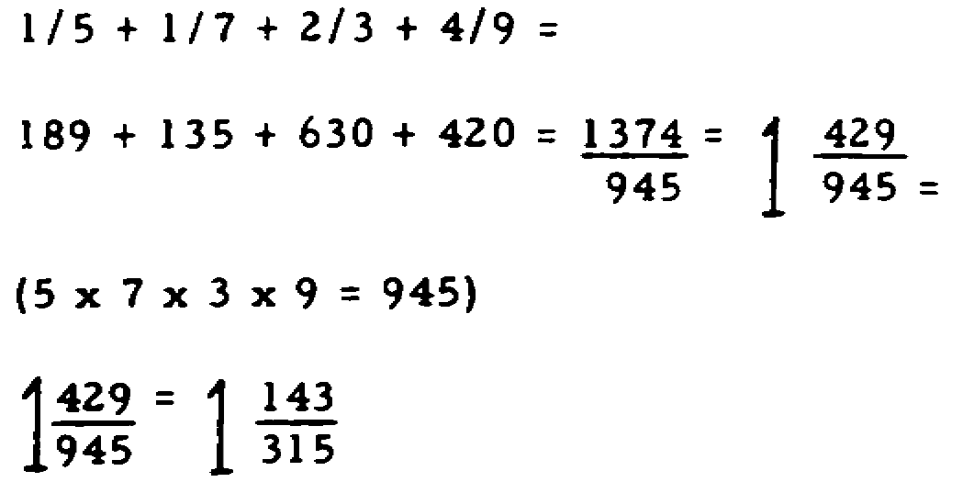
1. 1 143/315

2. 8/21 5/7 - 1/3 =

15/21 - 7/21 = 8/21

3. 9/10 2/5 x 9/4 =

2/5 x 9/4 = 18/20 - 9/10

86

4. 7 1/2 1 2/3 ÷ 2/9 =

5/3 ÷ 2/9 =

5/3 x 9/2 =

5/3 x 9/2 = 45/6 = 7 3/6 = 7 1/2

5. 4.8921 0.2450
3.2100
0.5340
0.0031
0.9000
4.8921

6. 0.4372 0.4400
- 0.0028
0.4372

7. 5.05012 1.004
x5.03
3012
502000
5.05012

87

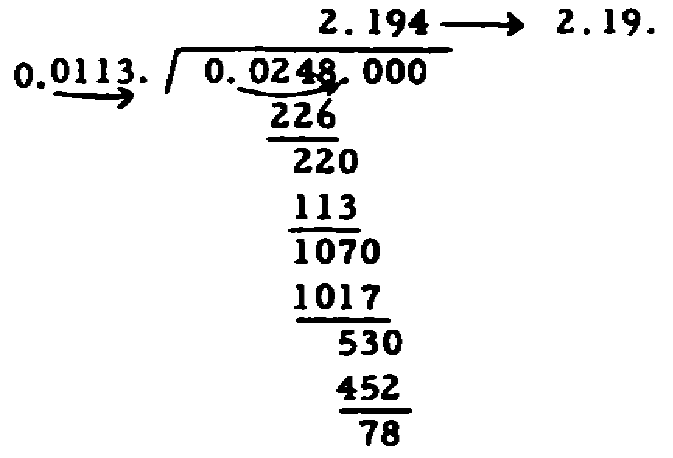
8. 2.19

9. Thousand

10. Milli

11. .000002 henries 2 ÷ 1,000,000 = .000002 henries

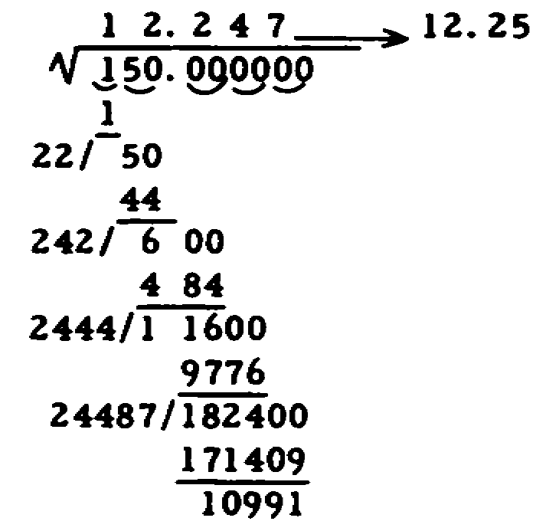
12. 12.25

88

SECTION 2

TABLE OF CONTENTS

Page Frame

1. What is a formula? 1 1

2. The symbols in a formula 15 8

3. Substituting and solving 23 12

4. The RT formula 7 19

5. Metric numbers 11 21

6. Solving problems using metric numbers 21 40

7. Converting base to metric 55 54


8. The formula 51 65

i

OBJECTIVES

SECTION 2

As a result of taking this section of BASIC MATHEMATICS, you must

be able to:

1. Solve problems using formulas.

2. Solve problems using metric numbers.

ii

INTRODUCTION

Much of electronics is concerned with arithmetic. The technician must be able to figure out resistances, voltages, current, etc. Fortunately, formulas have been developed to help you find these values. Formulas depend on your knowing certain values, from which you find an unknown value. In electricity, these values are often reported as metric numbers (such as 3 μ, 5M) for the sake of convenience.
No attempt is made in this text to establish a relationship between the formulas and numbers and the concepts of basic electricity. You will learn the meanings and applications of all of these formulas in other subcourses. By that time, you are expected to already be able to use the formulas to solve problems.
The frames in this section are arranged differently than those in Section 1. However, by following the directions given, you will be able to easily proceed through the text.

iii

1.

E = IR

This is a FORMULA. This text will teach you how to solve a
____________________.

Turn the page

DO NO READ DOWN THE PAGE.

29.

M stands for 1,000,000. 5M equals (number) ______________. To get the answer, you ______________ 5 times 1,000,00.

53.

Solve this problem without help.

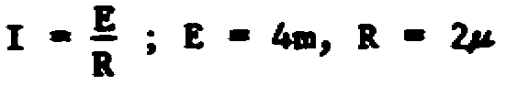

I = _________________

1

la.

formula

Turn the page

29a.

5,000,000

multiplied

53a.

I = 2000

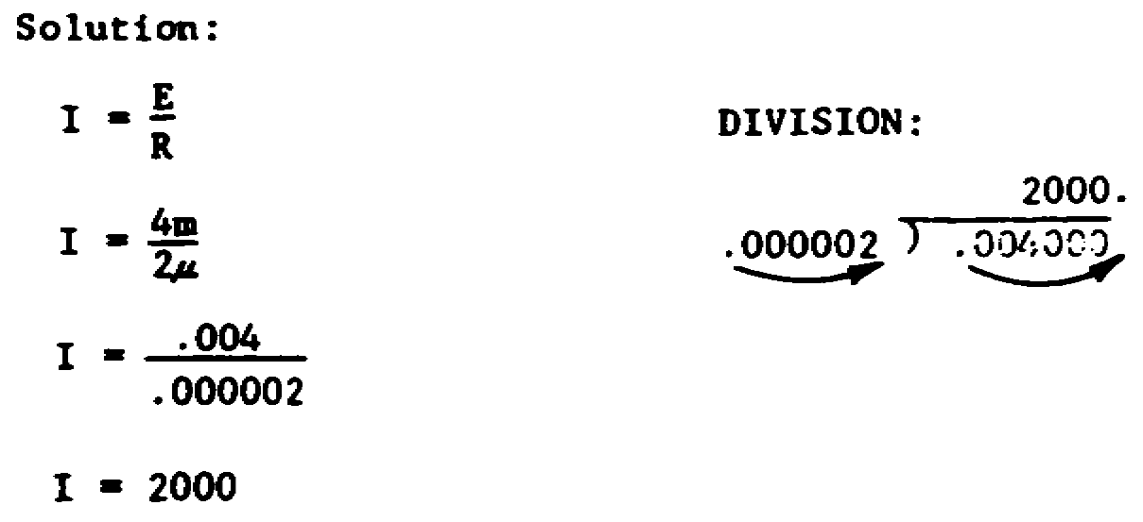

2

2.

A formula is like a rule. It tells you how to solve an arithmetic problem. It tells you how to find the correct ____________________________.

30.

Solve these multiplication problems.

.001 .001 .001

x 3 x 14 x 4.7

____ ____ _____

Now, convert these metric numbers. m stands for .001 (one thousandth).

3m = ___________________________

4.7m = _____________________________

14m = ___________________________

54.

Sometimes you must report the answer to a problem as a metric number. To do this, you must convert a base number to its _______________ equivalent.

3

2a.

answer

30a.

.003 NOTE: If you missed any of these,

.014 go back and find out exactly what

.0047 you did wrong. Do not make the

3m = .003 same mistake again.

4.7m = .0047

14m = .014

54a.

metric

4

3.

A = B + C

This formula tells you how to find A. You would use this formula if you wanted to find a value for __________.

31.

m stands for .001 (one thousandth).

Convert these metric numbers to base numbers.

1.4m = ___________________

2.86m = ________________________

.5m = ____________________

55.

Every number has a decimal point. (It doesn't always show.) You can convert a base number to a metric number by moving the _____________________.

5

3a.

A

31a.

.0014 NOTE: If you missed any of

.00286 these, go back and find out

.0005 exactly what you did wrong.

Do not make the same mistake

again.

55a.

decimal point

6

4.

E = I x R

When you use this formula, you will find a value for ______________.

32.

Practice multiplying decimal fractions. The important part (and the hardest) is getting the decimal point in the correct place.

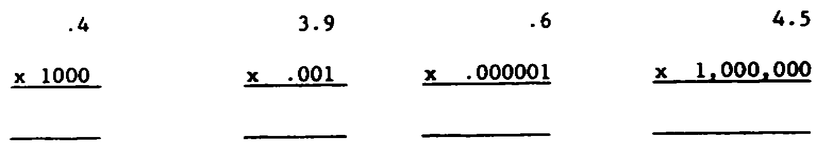

56.


You will move the decimal point either to the left or the right. On the scale below we have drawn an arrow from BASE to K. This shows that to change a base number to thousandths, you move the decimal point three places to the left. For example,

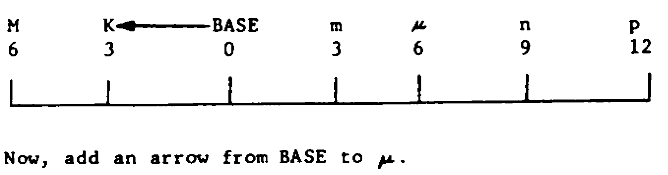

7

4a.

E

32a.

400 NOTE: If you missed any of

.0039 these, go back and find out

.0000006 exactly what you did wrong.

4,500,000 Do not make the same mistake

again.

56a.

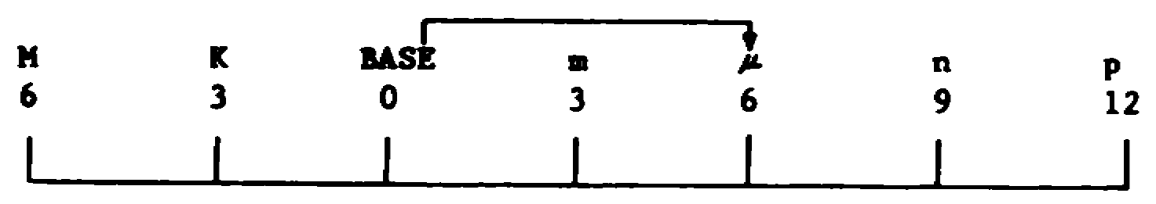

8

5.

You can solve any arithmetic problem by either adding or _______________ or multiplying or _______________.

33.

Practice some more.

.5 x 1,000,000 = ________________________

1.7 x .001 = ___________________________

3 x .000001 = __________________________

.006 x .001 = __________________________

57.

When converting from BASE to μ, you move the decimal six places to the right.

.006 = __________________ μ

9

5a.

subtracting

dividing

33a.

500,000 NOTE: If you are still missing

.0017 these problems, go back to step 30

.000003 and practice them all again. You

.000006 cannot learn any more until you do

this correctly -- so learn it now.

57a.

.006 = 6,000μ

10

6.

A formula tells you how to solve an arithmetic problem. It tells you whether to add or _______________ or multiply or _______________.

34.

μ (this is read as "micro") means .000001 (one millionth).

Convert these metric numbers to base numbers.

73μ = _______________________

.5μ = _______________________

8μ = _______________________

58.

Draw an arrow from BASE to M.

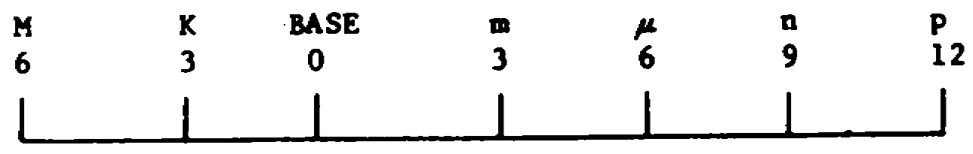

Which way will you move the decimal point to convert 6,000,000 to M? (Right/Left) ____________________

11

6a.

subtract

divide

34a.

.000073

.0000005

.000008

58a.

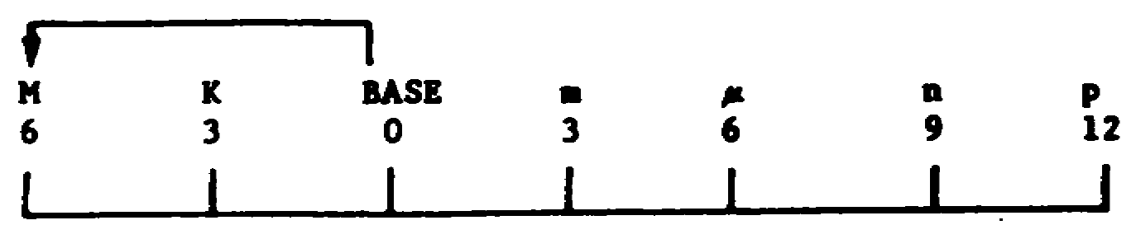

Left

12

7.

A formula does not actually say "add," "subtract," etc. It uses symbols. For example, "+" is a symbol meaning to __________.

35.

n (this is read "nano") means 0.000000001 (one billionth). Convert this metric number to its base equivalent.

75n = _________________________

.2n = _________________________

59.

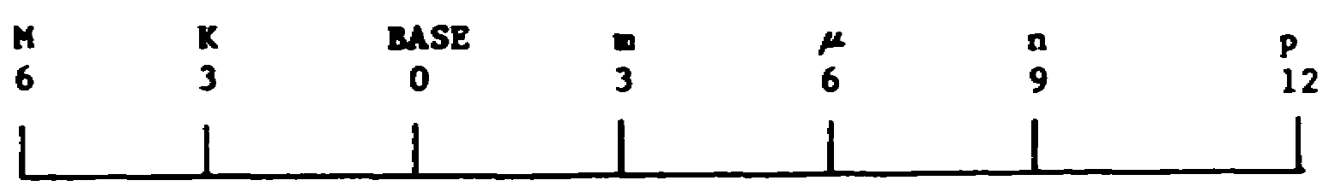

To convert from base to "m," we would move the decimal point (number) __________ places to the right.

13

7a.

add

35a.

0.000000075

0.0000000002

59a.

3

14

8.

Here are the symbols used in formulas.

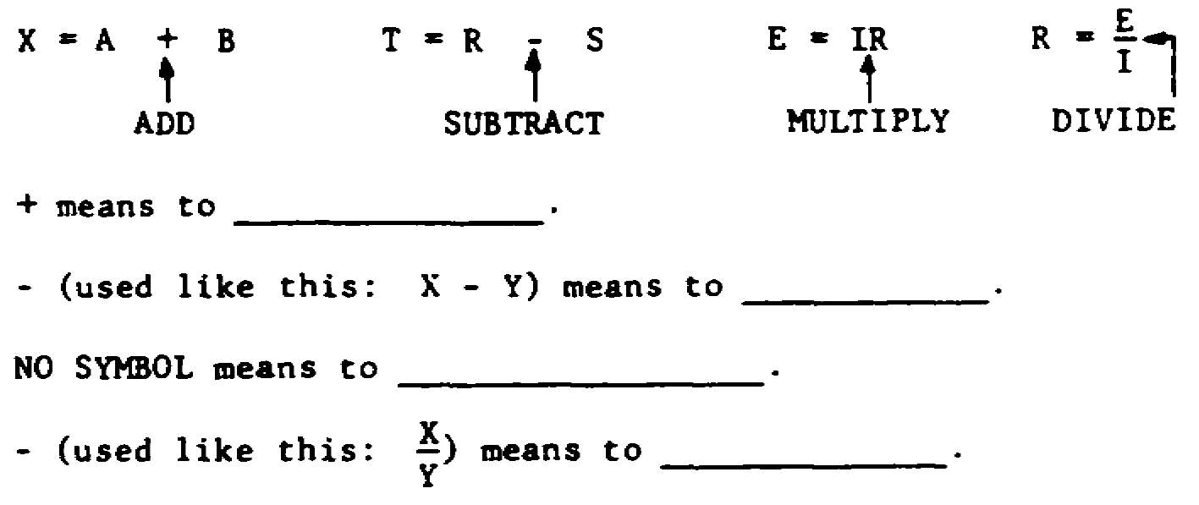

36.

p (this is read "pico") means 0.000000000001 (one trillionth). Convert this metric number to its base equivalent.

45p = _______________________

60.

Which is the correct conversion of base to μ. Circle the letter of the correct answer.

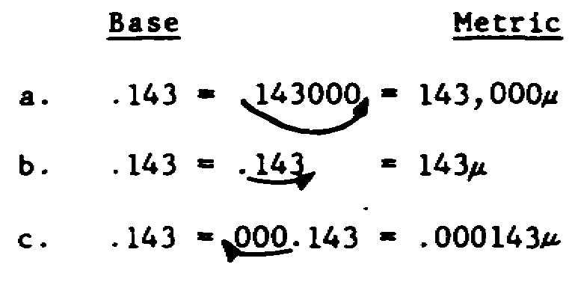

15

8a.

add

subtract

multiply

divide

36a.

0.000000000045

(You should have 10 zeros in your answer.)

60a.

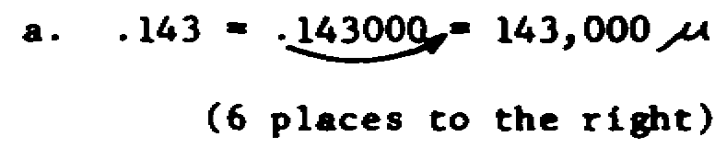

16

9.

What do these symbols mean?

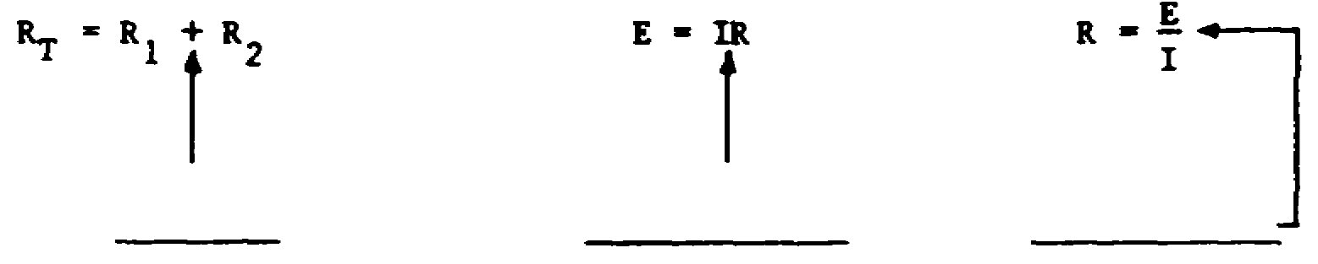

37. NOW, complete the following table:

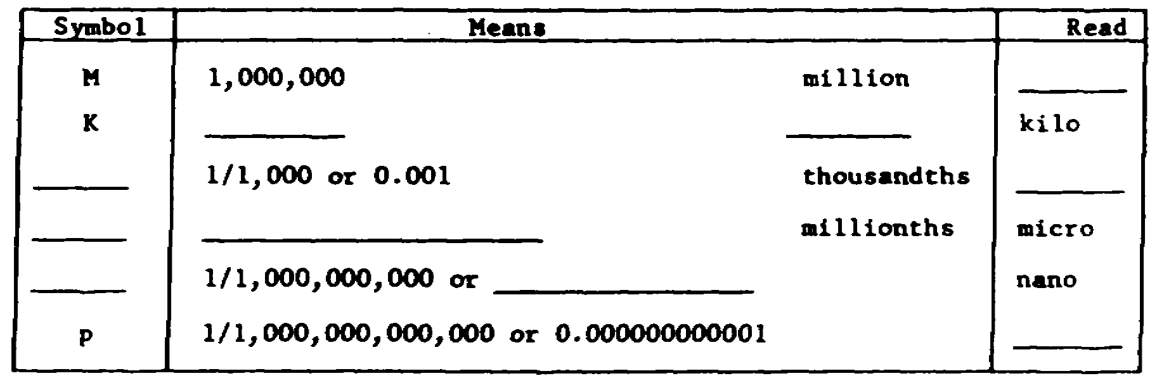

61.

Convert these numbers to metric.

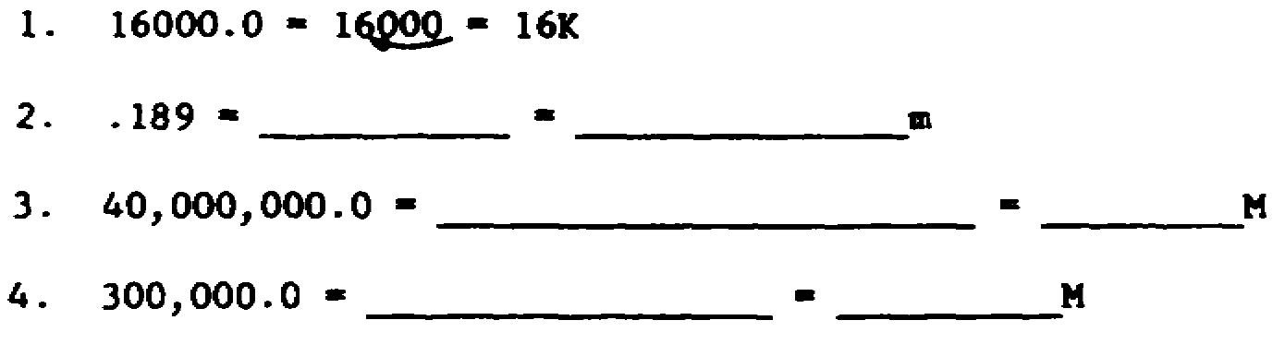

17

9a.

add

multiply

divide

37a.

METRIC SYSTEM TERMS

M 1,000,000 million mega

K 1,000 thousand kilo

m 1/1,000 or 0.001 thousandth milli

μ 1/1,000,000 or 0.000001 millionth micro

n 1/1,000,000,000 or 0.000000001 nano

p 1/1,000,000,000,000 or 0.000000000001 pico

61a.

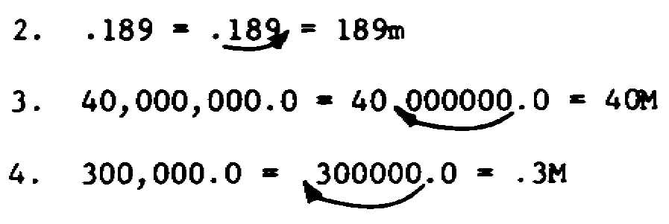

18

10.

A = B + C

This formula tells you how to find _____. You get the answer by (adding/subtracting) ______________ B and __________.

38.

You may use your METRIC NUMBER TABLE to help you answer these questions.

75μ = ____________________

16K = ____________________

3.5M = ________________________

.98m = ________________________

61b.

If you missed any of the problems on the last step, do the problems on this step. Otherwise, go on to the next step.

.14 = ____________________ = _____________________m

4,100,000 = ______________________ = __________M

19

10a.

A

adding

C

38a.

.000075

16,000

3,500,000

.00098

61c.

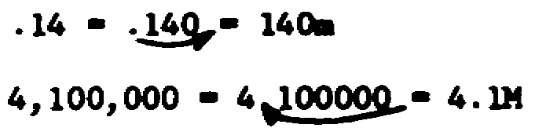

20

11.

E = IR

How would you find E? *

38b.

If you missed the last step, number 38, take this step. If you got the last step correct, skip this step.

3μ = ___________________________

45K = __________________________

.17M = ____________________________

1.4m = ____________________________

62.

Now solve this problem. Report the answer in M.

E = IR; I = 3K, R = 6K

E = _____________M

21

11a.

*By multiplying I times R

NOTE: This step has an asterisk (*). Your answer need not be in the exact words. The important thing is that your answer mean the same thing.

38c.

.000003

45,000

170,000

.0014

62a.

E = 18M

Solution:

E = IR

E = 3K x 6K

E = 3000 x 6000

E = 18,000,000

E - 18M

22

12.

E = IR

This formula tells you how to find E. It tells you to multiply I times R. But you cannot multiply letters. You can only multiply ______________________.

39.

Throughout your electricity and electronics course, you will be asked to solve formulas. The numbers you will use will often be in this form: 5K, 38m, etc. These are called ______________________ numbers.

63.

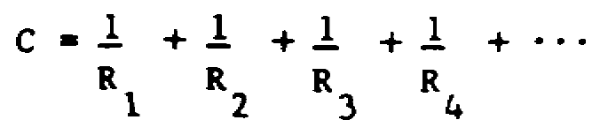

This formula looks similar to RT = R1 + R2 + R3 + R4 + . . .. However, if you look closely you will see that it is ____________________ the same.

23

12a.

numbers

39a.

metric

63a.

not

24

13.

RT = R1 + R2

Before you can add, you must replace the letters R1 and R2 with ____________________.

40.

E = IR; I = 5m, R = 2K

E = 5m x 2K

In any problem using a formula, the first step is to replace the letters with numbers. Look at the example above. We replaced the letters (I and R) with ___________________ numbers (5m and 2K).

64.

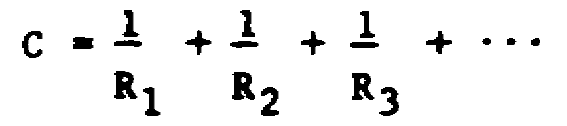

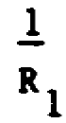
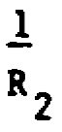
and are fractions. So far, you have only been required to add whole numbers. This formula requires you to add _____________________.

25

13a.

numbers

40a.

metric

64a.

fractions

26

14.

Here is a formula RT = R1+ R2

Here are the replacement numbers R1 = 5, R2 = 7

Here we replaced the letters with numbers RT = 5 + 7

Here we solved the formula (by adding) RT = 12

NOW YOU DO IT:

Here is the formula E - IR

Here are the replacement numbers I = 2, R = 3

DO THIS REPLACE THE LETTERS WITH NUMBERS E = _____ x _____

DO THIS SOLVE THE FORMULA (by multiplying) E = _________

41.

If you try to add 3 apples and 4 oranges, you won't know what to call the answer. (orples?)

Can you add 3M and 4K? *

65.

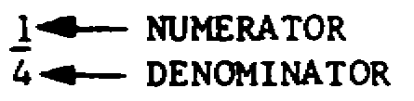

The bottom part of a fraction is called the _____________________.

27

14a.

E = 2 x 3

E = 6

41a.

* Not in this form.

65a.

denominator

28

15.

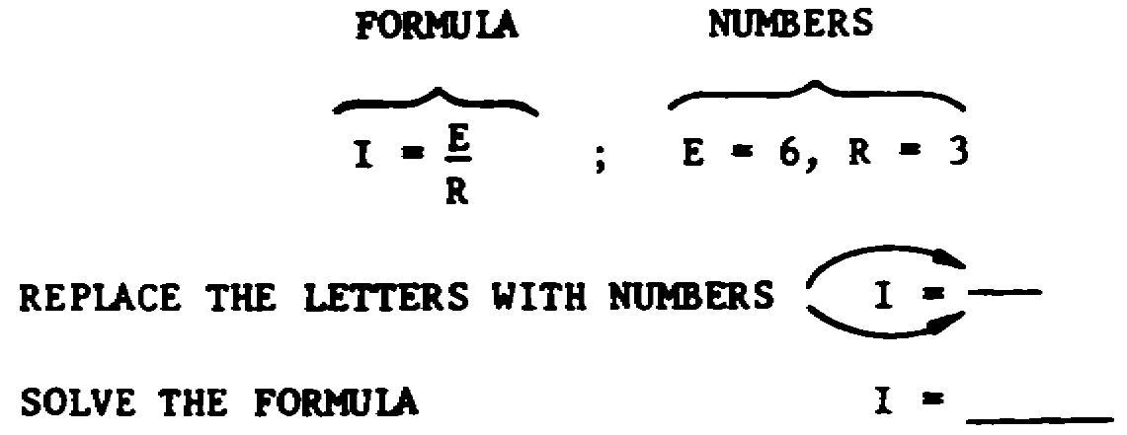

42.

3M + 4K = ?

There are two ways to solve this problem.
A. Change both metric numbers to a common metric term, such as 3000K + 4K.
B. Change both metric numbers to their base equivalents, 3,000,000 + 4,000.
Since you already know how to do B, in this text we will use ________.

66.

Two fractions are equivalent if both can be reduced to the same fraction. For example, 1/3 = 15/45 because 15/45 can be reduced to 1/3 by dividing both numerator and denominator by 15.
Is it true that 4/10 = 12/30?

29

15a.

I = 6/3

I = 2

42a.

B

66a.

Yes, because 4/10 = 2/5 and 12/30 = 2/5.

30

16.

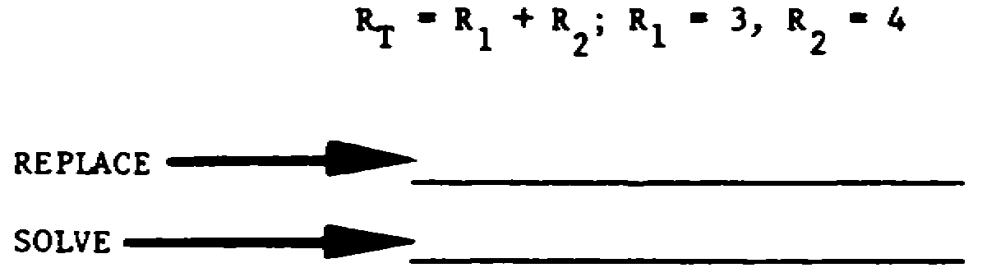

43.

RT = R1 + R2 + R3 + R4 + ... ; R1 = .3K, R2 = 78m

REPLACE: RT = .3K + 78m

CONVERT: RT = 300 + .078

SOLVE: RT = 300.078

What are the three steps to solving a formula using metric numbers?

1. ________________________

2. ________________________

3. ________________________

67.

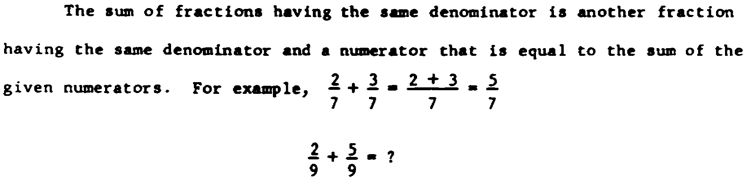

31

16a.

RT = 3 + 4

RT = 7

43a.

1. Replace (Also called substitute)

2. Convert

3. Solve

67a.

7
9

32

17.

Solve this problem.

E = IR; I = 2, R = 5

44.

Normally, to solve a formula you take two steps: substitute and solve. An extra step should be added when you are given metric numbers. The extra step is _______________________.

68.

When several fractions have the same denominator, we say they have a COMMON DENOMINATOR. The fractions 2/13, 5/13, and 7/13 have a _____________ ______________.

33

17a.

E =10

Solution:

E = 2 x 5

E = 10

44a.

convert

68a.

common denominator

34

18.

Solve this problem.

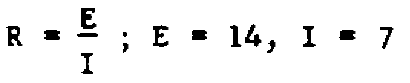

45.

Do you know how to substitute? _____________

Do you know how to convert? ____________

Do you know how to solve? ________________

69.

In adding fractions with different denominators it is customary first to replace the fractions with equivalent fractions having the same (a common) denominator. For example,

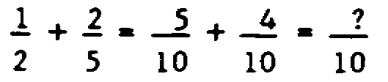

35

18a.

R = 2

Solution:

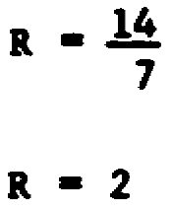

45a.

yes NOTE: As you know, you have

yes just learned how to do each

yes of these three things in this

lesson.

69a.

9

36

19.

RT = R1 + R2 + R3 + R4 + ...

The RT formula is usually written this way. The three dots, ..., simply mean that you use as many R's as you are given. If you are given two R's, then you would add together _________ R's.

46.

Solve these formulas. Use your metric number table.

1. RT = R1 + R2 + R3 + R4 + ...; R1 = 5K, R2 = .4M

RT = ________________

2. E = IR; I = 3m, R = 3K

E = _________________

70.

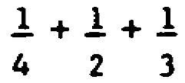

The first step to solving this problem would be to find a ____________ denominator.

37

19a.

two

46a.

1. RT = 405,000
Solution:
RT = R1 + R2 + R3 + R4 + ...
RT = 5K + .4M
RT = 5000 + 400,000
RT = 405,000
2. E = 9
Solution:
E = 1R
E = 3m x 3K
E = .003 x 3000 E = 9

70a.

common

38

20.

Solve this problem:

RT = R1 + R2 + R3 + R4 + ... ; R1 = 1,000, R2 = 5,000, R3 = 3,500

46b.

If you missed either of the problems in the last step, solve this problem. If you did not miss them, skip this problem.

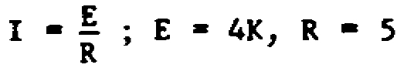

I = _______________

71.

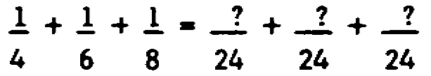

4, 6, and 8 will all divide 24. Therefore, 24 can be the common denominator for these fractions.
A common denominator is a number that can be ______________ by all the denominators.

39

20a.

RT = 9500

Solution:

RT = 1000 + 5000 + 3500

RT = 9500

46c.

I = 800

Solution:

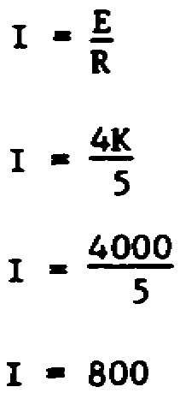

71a.

divided

40

21.

We often use METRIC numbers in a formula. The following steps will teach you how to use _________________ numbers.

47.

See if you can answer these questions, from memory.

M stands for __________________________

K stands for __________________________

m stands for __________________________

μ stands for __________________________

n stands for __________________________

p stands for __________________________

72.

Find a common denominator for each of these problems. Try to find the lowest one possible.
1. 1/4 + 1/6 common denominator = ________________

2. 1/8 + 1/2 common denominator = ________________

3. 1/3 + 1/5 + 1/6 common denominator = ________________

41

21a.

metric

47a.

(M) 1,000,000 (one million)

(K) 1,000 (one thousand)

(m) .001 (one thousandth)

(μ) .000001 (five 0's)

(n) .000000001 (eight 0's)

(p) .000000000001 (eleven 0's)

72a.

1. 12 is the lowest common denominator
(other common denominators are 24, 36, etc.)

2. 8 is the lowest common denominator
(other common denominators are 16, 24, etc.)

3. 30 is the lowest common denominator
(other common denominators are 60, 90, etc.)

42

22.

5m

This is a METRIC number. Very large numbers (such as 3,500,000) are often reported as metric numbers. Very small numbers (such as .000000000003) are also often reported as _______________________________.

47b.

If you missed any of the problems on the last step, do them again here. YOU MUST KNOW THESE VALUES. If you did not miss them, go on to the next step.

M = ________________________

K = ________________________

m = ________________________

μ = ________________________

n = ________________________

p = ________________________

73.

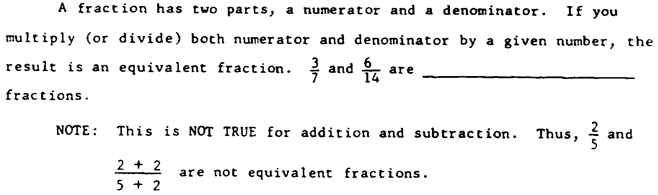

43

22a.

metric numbers

47c.

M = 1,000,000 (one million)

K = 1,000 (one thousand)

m = .001 (one thousandth)

μ = .000001 (five 0's)

n = .000000001 (eight 0's)

p = .000000000001 (eleven 0's)

73a.

equivalent

44

23.

There are many ways to write "five million." You can write "5,000,000," but that's a lot of 0's. You can write "5 million," but that's still pretty long. Suppose we abbreviate "million" to "M." Then we can write 5______.

48.

Below, we have written the metric symbols out of sequence. See if you can write the correct value for each one, from memory.
K stands for _______________________

p stands for _______________________

m stands for _______________________

M stands for _______________________

μ stands for _______________________

n stands for _______________________

74.

If you multiply the denominator by 5, you must multiply the numerator by 5. If you multiply the denominator by 16, you must multiply the numerator by ______________.

45

23a.

M

48a.

(K) 1,000 (one thousand)

(p) .000000000001 (eleven 0's)

(m) .001 (one thousandth)

(M) 1,000,000 (one million)

(μ) .000001 (five 0's)

(n) .000000001 (eight 0's)

74a.

16

46

24.

You can change 3,000,000 to 3M as long as you remember that "M" means one ____________________.

48b.

If you missed any of the problems on the last step, do them again here. Otherwise, skip this step.
m = ___________________________

K = ___________________________

P = ___________________________

M = ___________________________

μ = ___________________________

n = ___________________________

75.

Circle all pairs of equivalent fractions.

47

24a.

million

48c.

m = .001 (one thousandth)

K = 1,000 (one thousand)

p = .000000000001 (eleven 0's)

M = 1,000,000 (one million)

μ = .000001 (five 0's)

n = .000000001 (eight 0's)

75a.

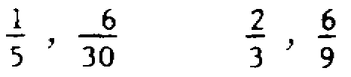

48

25.

Let "M” stand for one million. Abbreviate these numbers.

4,000,000 = ______________

7,000,000 = _____________

16,000,000 = _______________

49.

Solve this problem.

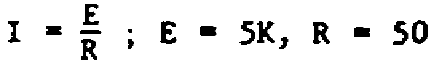

I = _______________

76.

Figure out the numerators.

49

25a.

4M

7M

16M

49a.

I = 100

Solution:

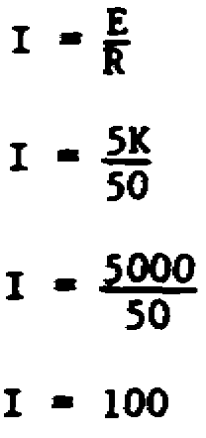

76a.

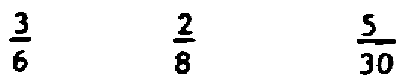

50

26.

Let "K" stand for 1000. Abbreviate these numbers.

7,000 = ________________

4,000 = ________________

161,000 = ____________________

50.

Solve this problem without help.

RT = R1 + R2 ; R1 = 7K, R2 = 89

RT = ____________________

77.

The common denominator is 12. Change each numerator.

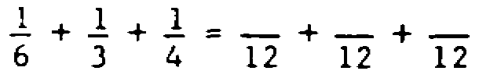

51

26a.

7K

4K

161K

50a.

RT =7,089

Solution:

RT = R1 + R2

RT = 7K + 89

RT = 7,000 + 89

RT = 7,089

77a.

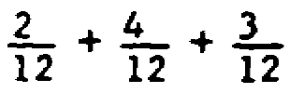

52

27.

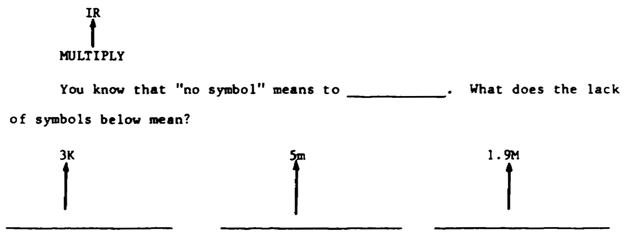

51.

Solve this formula without help.

E = IR; I = 2m, R = 17K

E = ___________________

78.

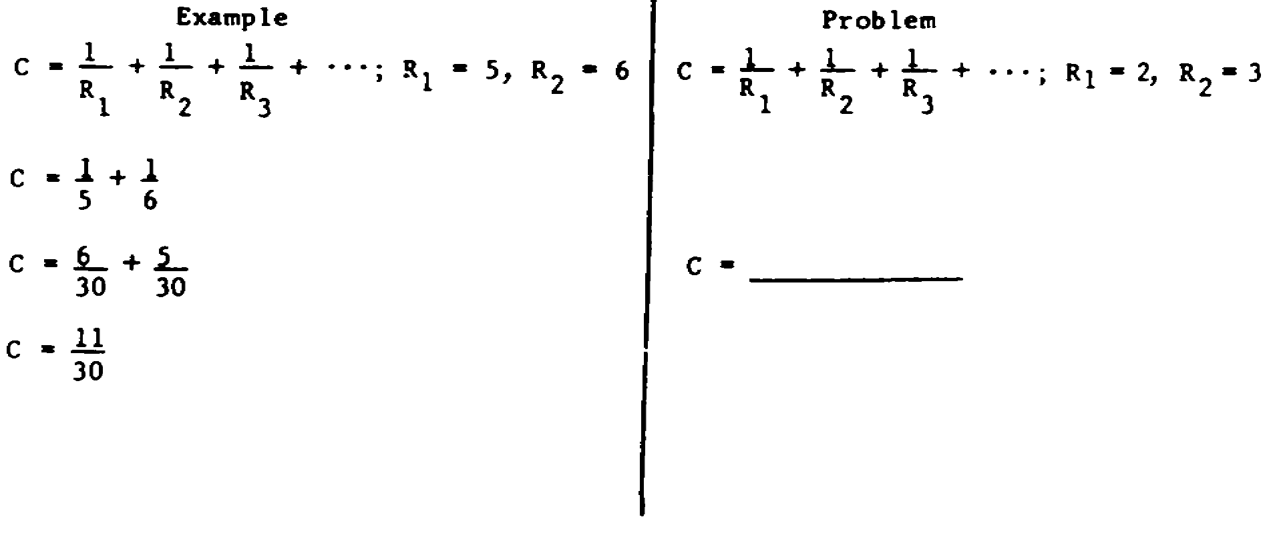

53

27a.

multiply

multiply

multiply

multiply

51a.

E = 34

Solution:

E = IR

E = 2m x 17K

E = .002 x 17,000

E = 34

78a.

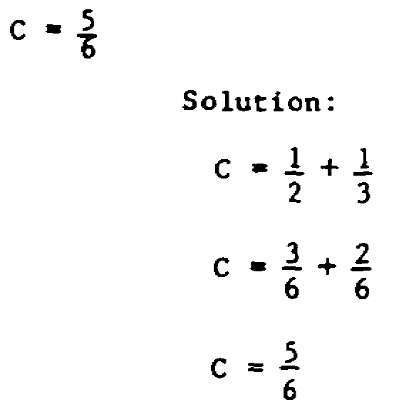

54

28.

M = 1,000,000 K = 1000 m = .001

When you see 5M, you know that it means 5 multiplied by 1,000,000. When you see 13K, you know that it means 13 ________________ by 1000. When you see 7m, you know that it means * .

52.

Solve this problem without help.

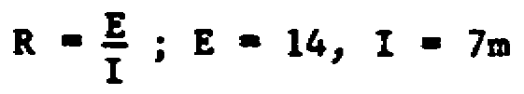

R = __________________

END OF TEXT

55

28a.

multiplied

*7 multiplied by .001

NOTE: TURN BACK TO PAGE 1 WHERE YOU WILL FIND STEP NUMBER 29.

52a.

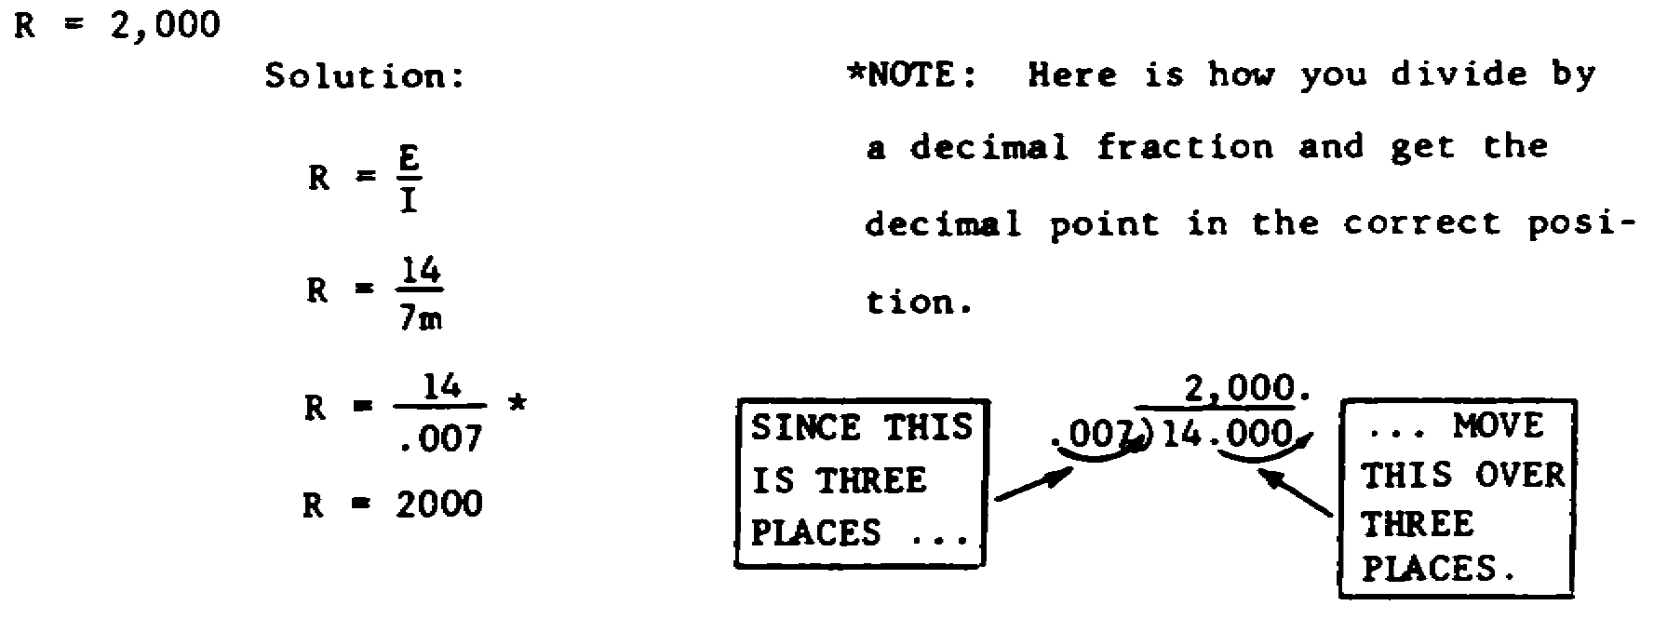

NOTE: TURN BACK TO PAGE 1 WHERE YOU WILL FIND STEP NUMBER 53.

HOLD ALL MATERIALS FOR USE WITH EXAMINATION.

*U.S. Government Printing Office: 2001 - 628-075/40412

56

